CPAN 228 – ONB

WEB APPLICATION DEVELOPMENT

Final Project

BARBARA TOSETTO

N01535342

HUMBER COLLEGE

JULY 2024

INTRODUCTION

This report provides a comprehensive overview of the software architecture implemented in the final project for Web Application Development , which revolves around a web-based restaurant management system. The system is designed to streamline the administration of a restaurant's operations, from managing the menu to handling user authentication and security. The system's backend is developed using Java, with Spring Boot as the primary framework facilitating both the development and the orchestration of the business logic.

STEP 1

Create a new project on Eclipse with the dependencies required below:

* Thymeleaf
* Spring Data JDBC
* Spring Data JPA
* Spring Web
* H2 Database
* Lombok
* Spring DevTools
* Springboot Starter Web

STEP 2 – Application Architecture

Organizing a Spring Boot application into directories ensures that the application is scalable, maintainable, and robust. Each directory has a specific role that supports the application's structure, promoting clean architecture principles where business logic, data access, and configuration settings are cleanly separated.

This approach not only aids in development but also simplifies troubleshooting and enhances the collaborative aspects of development by allowing team members to focus on specific aspects of the application without interference.

For this project the directories are: Config, Controllers, Models, Repositories and Services, as follow:

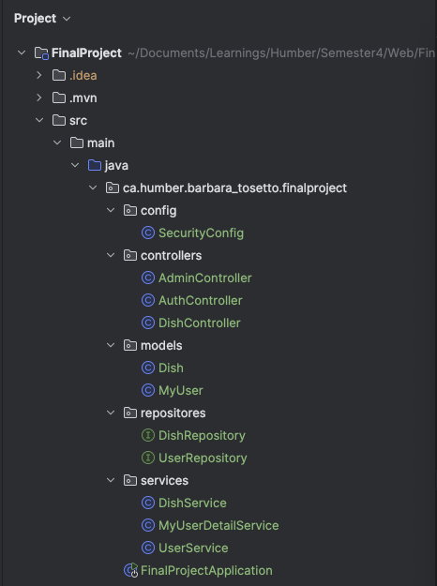

STEP 3 - Models

The models package contains entity definitions used within the application, such as Dish and MyUser. These models are annotated with JPA (Java Persistence API) annotations, allowing them to be easily stored and retrieved from a relational database.

Both the Dish and MyUser classes are fundamental components of this application's data layer, interacting directly with the database and serving as the primary method of data transport across the application. They ensure that data handling is streamlined and consistent with the application's object-oriented design.

Furthermore, their structured format, enforced through JPA annotations, enhances data integrity and interaction with the Spring Data JPA framework.

This structure supports efficient data operations and integration with other components like services and controllers, ultimately contributing to a robust and maintainable application architecture.

**Dish Class**

The Dish class represents a dish that can be ordered in the restaurant. The attributes are: id, name, category and price.

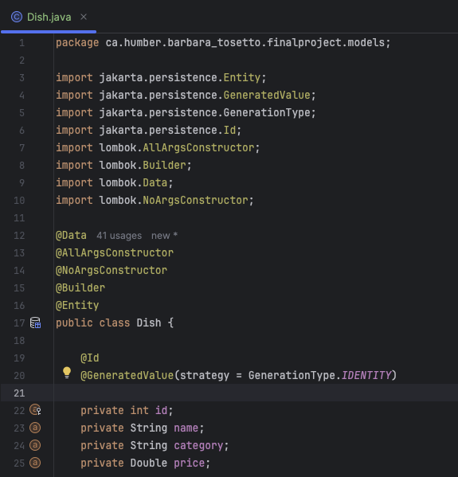

**MyUser Class**

The MyUser class represents a user of the system, storing credentials and roles necessary for authentication and authorization. The attributes are id, username, password and role.

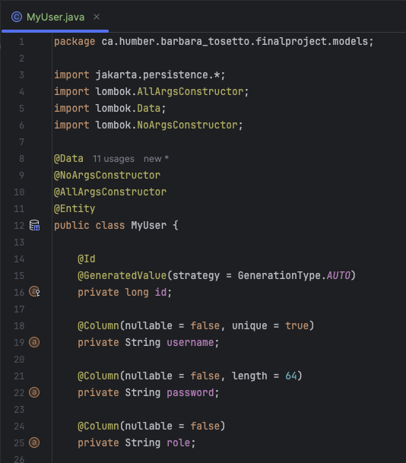

STEP 4 - Controllers

**Controller Classes**

The controllers package includes classes that handle incoming HTTP requests and dispatch responses. The controllers such as AdminController, AuthController, and DishController provide endpoints for tasks such as adding, deleting, and updating dishes, as well as managing user authentication and registration processes.

**DishController Class**

The DishController class in this application plays a crucial role in handling web requests related to dish management. This controller facilitates operations such as displaying dishes, adding new dishes, updating existing dishes, and deleting dishes. Let’s delve into the functionalities, methods, and routing handled by DishController.

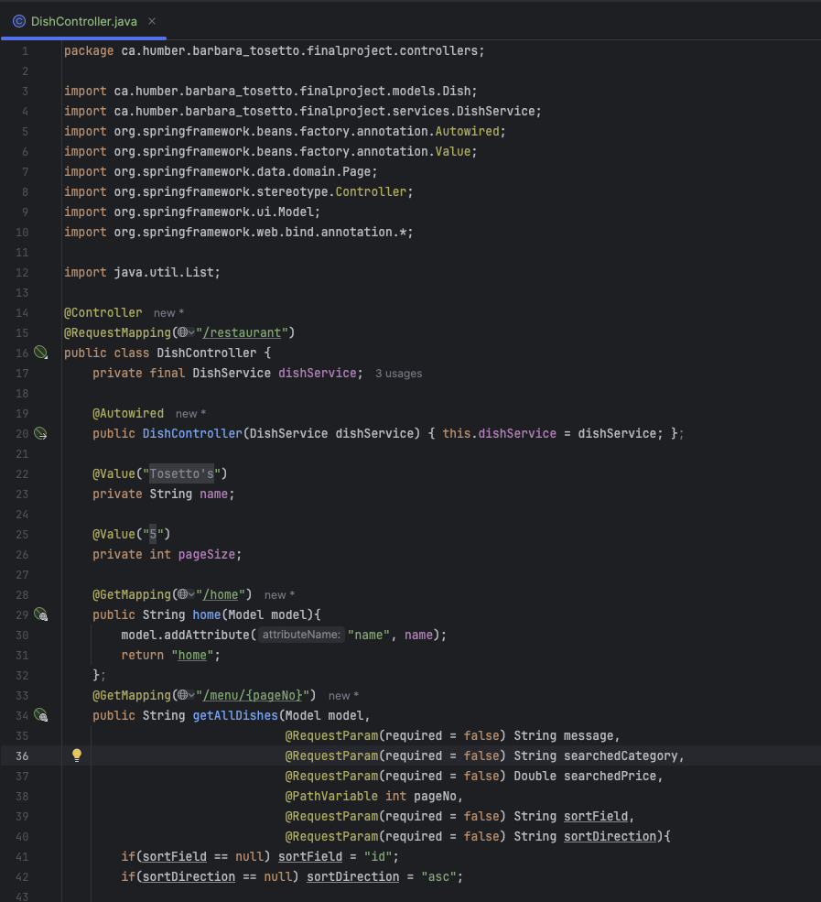

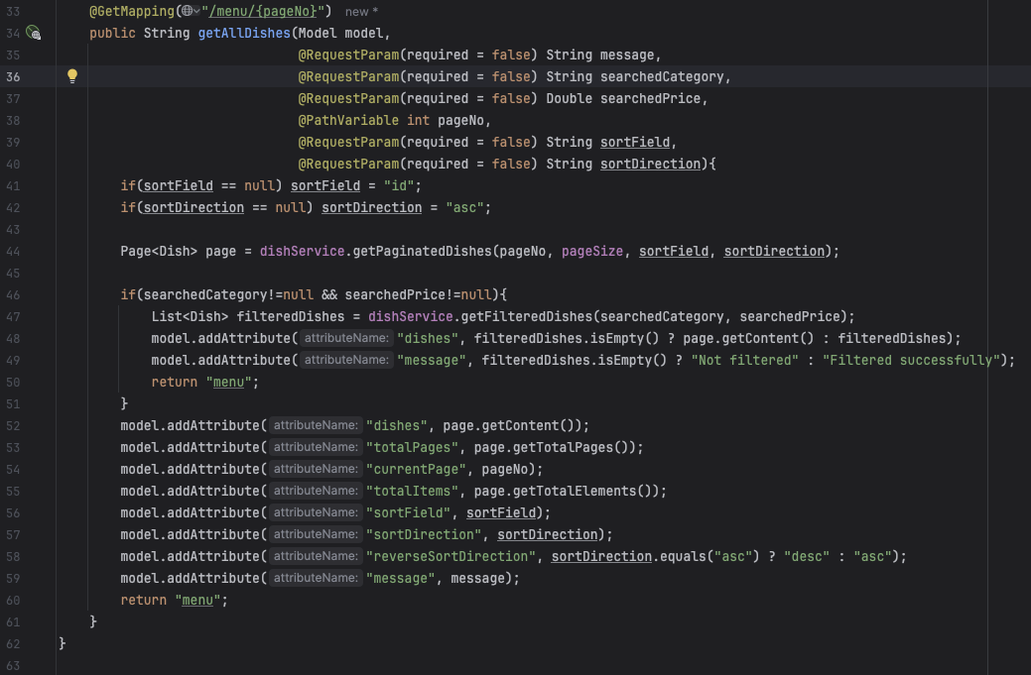

**AuthController Class**

The AuthController class in this Spring Boot application is central to managing authentication and authorization functionalities. This controller ensures users can log in, log out, and register, providing a secure and user-friendly way to handle access to various parts of the application.

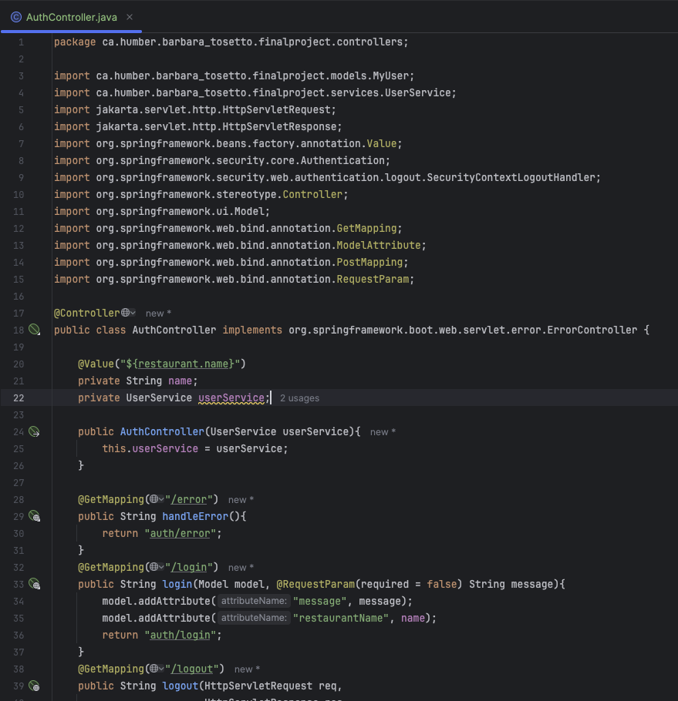

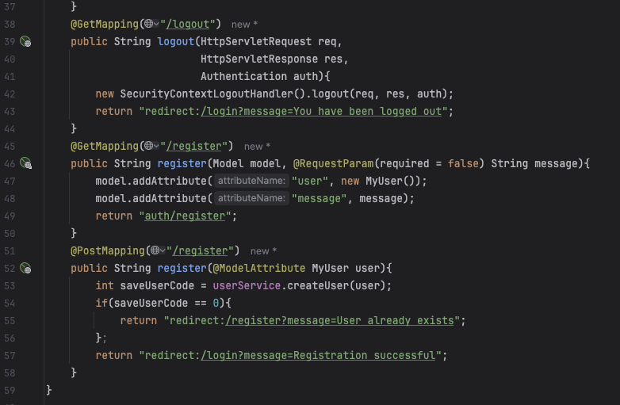

**AdminController Class**

The AdminController in this Spring Boot project is a crucial component that facilitates the administrative management of the restaurant's offerings, specifically focusing on the operations related to dish management. This controller provides backend functionality for adding, updating, and deleting dishes, essential tasks for maintaining the restaurant's menu

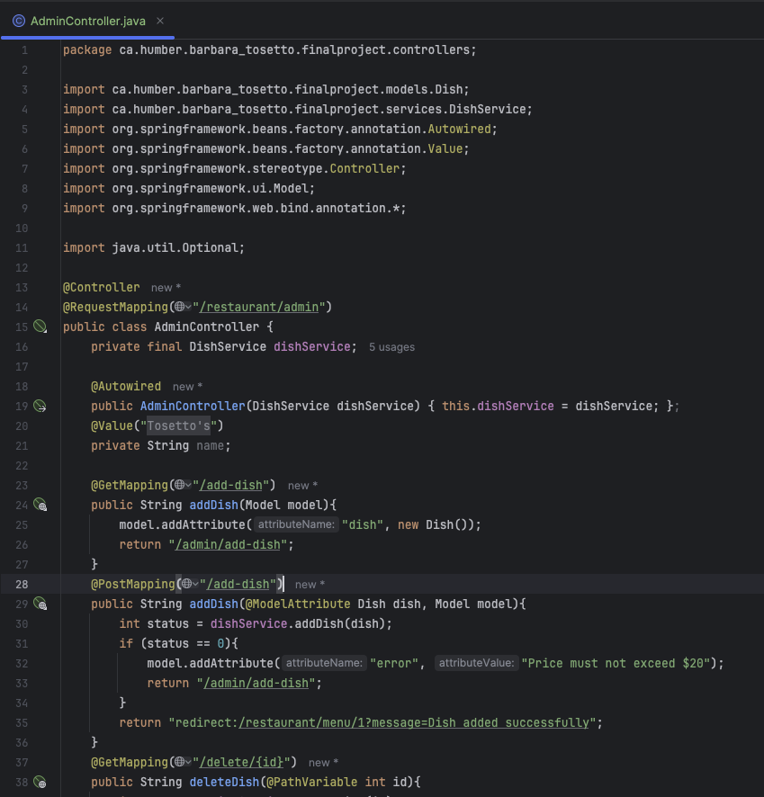

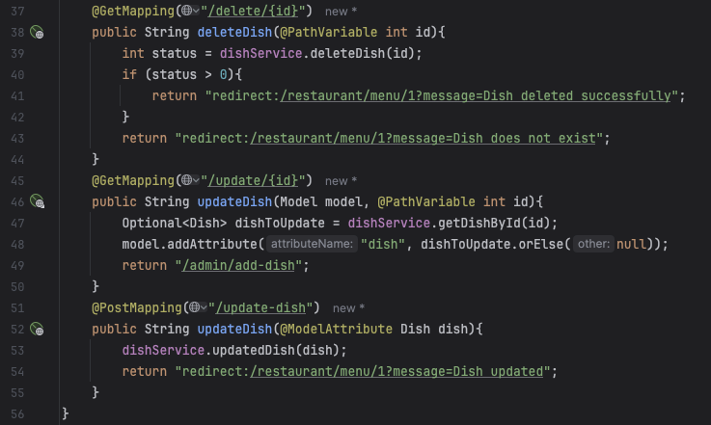

STEP 5 – Services Class

The three service classes—DishService, UserService, and MyUserDetailsService—serve critical roles in encapsulating the business logic, managing data interactions, and integrating with the security framework of the application.

Each of these services is designed to handle specific functionalities that ensure the system operates efficiently, securely, and remains maintainable.

**DishService Class**

The DishService class acts as a core component of the service layer, dealing directly with the business logic related to dish management. This class interfaces with the DishRepository , which will be explained later, to execute data access and manipulation tasks, ensuring that business rules and logic are correctly applied before any interactions with the database.

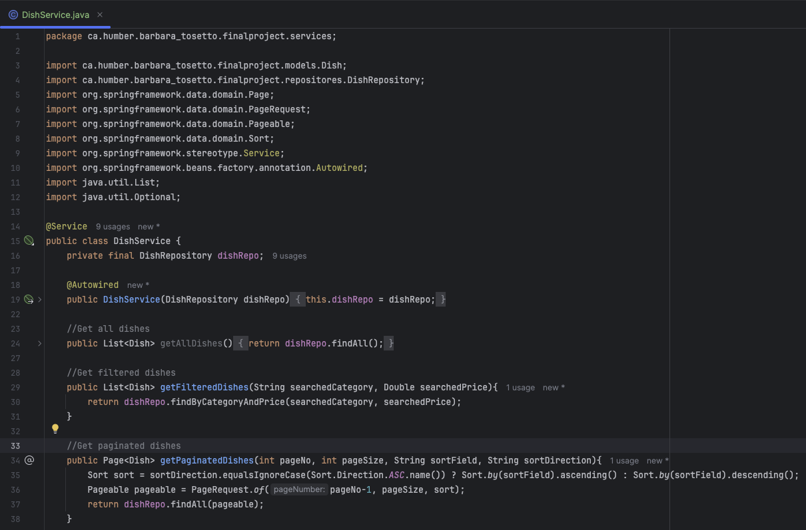

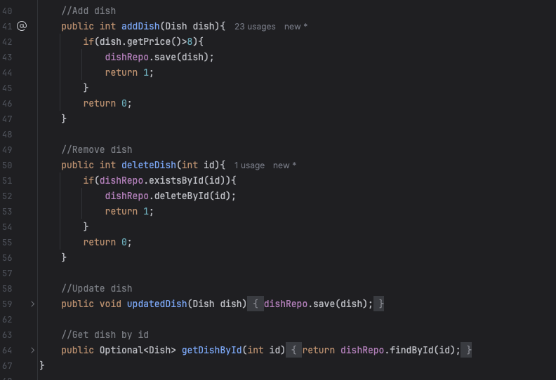

**MyUserDetailService Class**

The MyUserDetailService in this application is essential for integrating user authentication with Spring Security. It implements the UserDetailsService interface, specifically the loadUserByUsername method. This method retrieves user details from the database using the username, constructs a UserDetails object with credentials and roles, and then hands it off to Spring Security for authentication. This ensures that user logins are secure and managed in line with the stored credentials and roles.

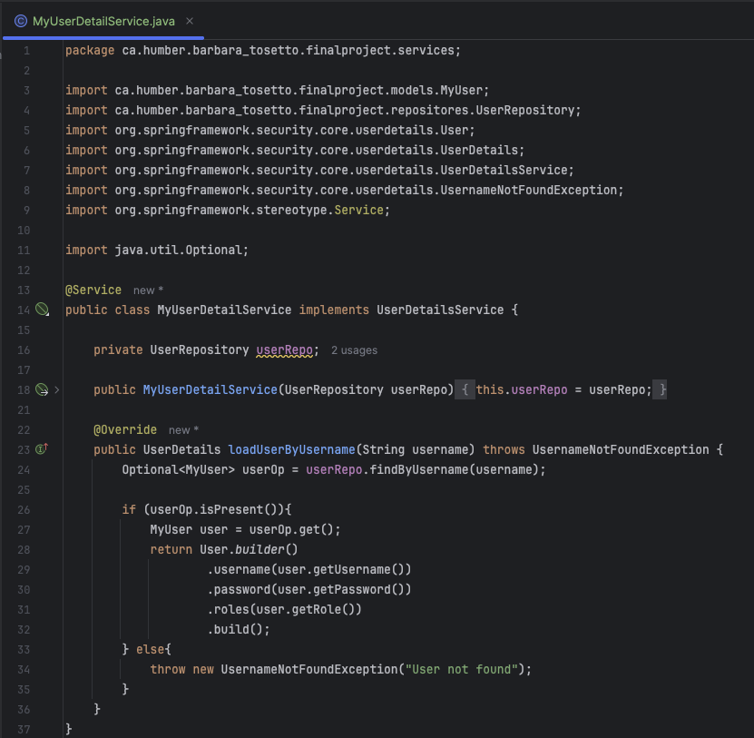

**UserService Class**

The UserService class is pivotal for managing user-related operations such as registration, password encryption, and the persistence of user data. It interacts with the UserRepository to perform CRUD operations on user data. When a new user registers, the UserService checks for the uniqueness of the username, encrypts the password using BCrypt for security, and then stores the user details in the database. This service centralizes user management tasks, ensuring data integrity and enforcing security measures crucial for protecting user information.

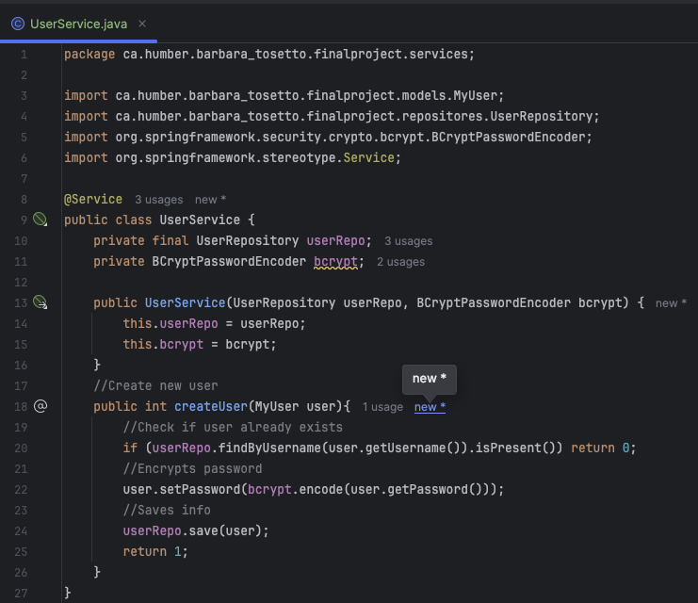

STEP 6 - Repositories

The repositories in this Spring Boot application, DishRepository and UserRepository, act as essential data access layers, extending JpaRepository to facilitate CRUD operations and specialized queries like findByUsername and findByCategoryAndPrice. These repositories streamline database interactions, simplifying the management of dish and user data with robust, easy-to-maintain methods that support the application’s core functionalities.

**DishRepository**

The DishRepository acts as the data access layer for managing the Dish entity, extending JpaRepository to provide comprehensive CRUD operations and custom queries like findByCategoryAndPrice. This repository simplifies complex database interactions, enabling efficient and targeted data retrieval and management, crucial for the application’s functionality.

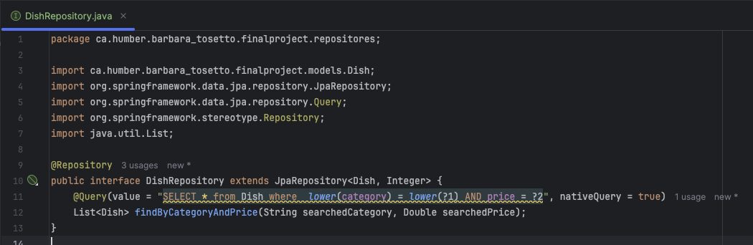

**UserRepository**

The UserRepository is crucial for accessing and managing user data stored in the database. It extends JpaRepository, offering built-in methods for CRUD operations, and includes a custom query method, findByUsername, which allows for fetching user details based on their username. This repository simplifies user data management, facilitating efficient and secure user authentication and profile management within the application.

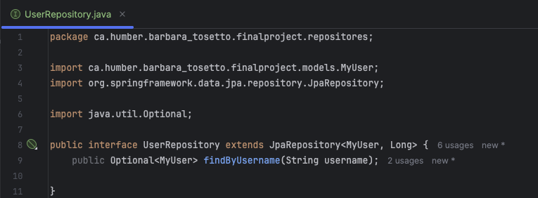

STEP 7 - Security

The SecurityConfig class configures security settings to manage authentication and authorization across the application. It defines rules for securing endpoints, specifies URL access permissions based on user roles, and sets up form-based authentication and logout functionalities. Utilizing Spring Security’s HttpSecurity, the class ensures that only authenticated users can access certain resources, enhancing the overall security posture of the application. This class is central to enforcing security measures that protect sensitive data and user interactions within the system.

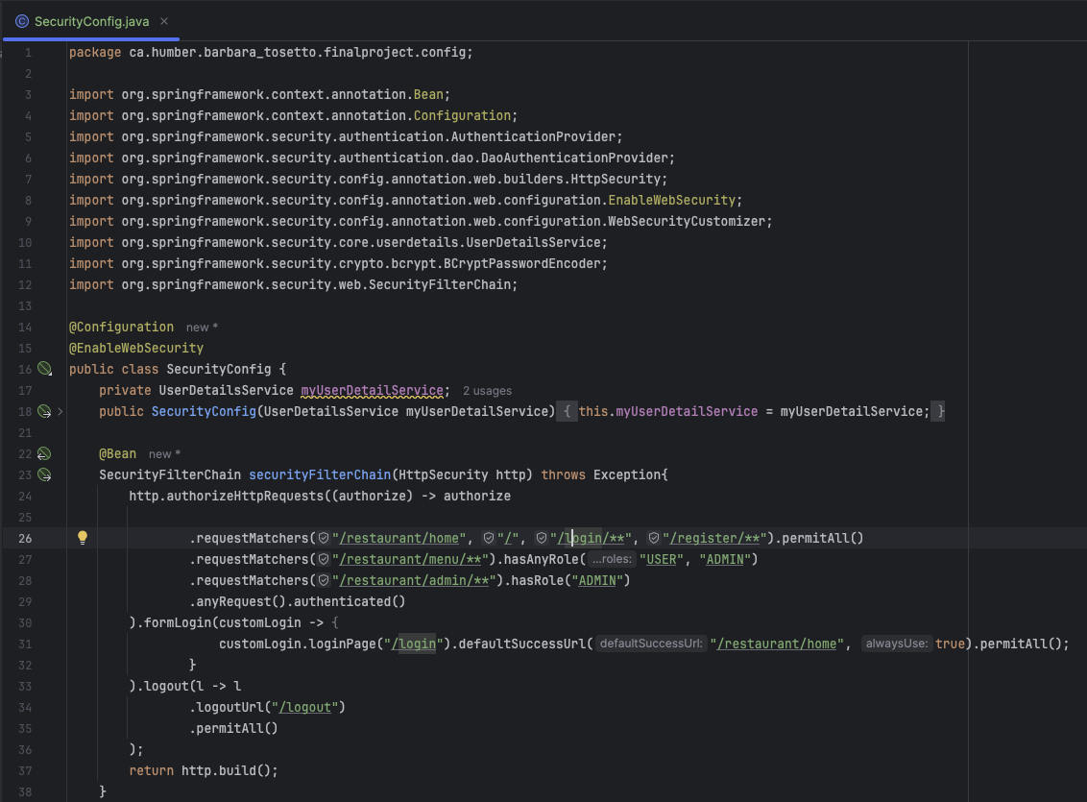

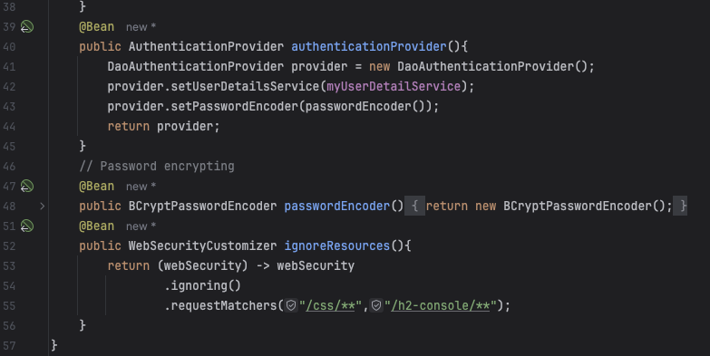

STEP 8 – Set up and configuration

The FinalProjectApplication class in this Spring Boot project is the main entry point, configured with @SpringBootApplication to facilitate auto-configuration and component scanning. It implements CommandLineRunner to execute initial data loading after the application starts. Within its run method, it uses DishService to pre-load the database with a set of dish entities. This automatic data population is crucial for initializing the application with default values for immediate functionality upon startup, enhancing testing and development workflows.

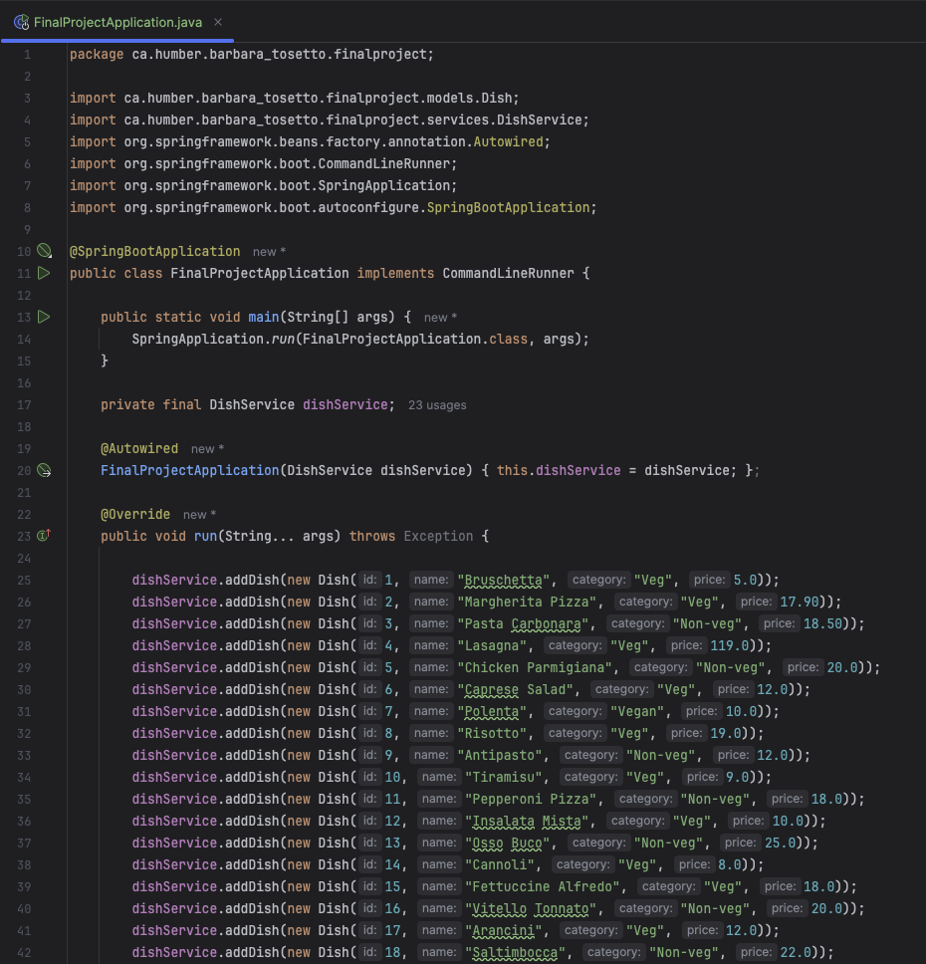

STEP 9 – Front-end Pages

The front-end of this Spring Boot application is structured to provide a dynamic and user-friendly interface, primarily managed through Thymeleaf templates located in the templates directory. These templates are HTML files enriched with Thymeleaf syntax, allowing for server-side rendering of dynamic content.

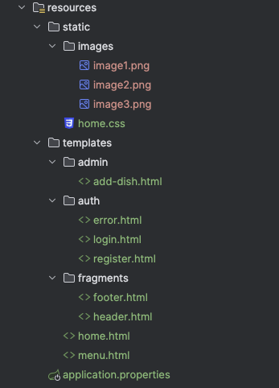

**Main Templates**

Including key pages like home.html, menu.html, and others, which serve as the primary interaction points for users, displaying content like menus and home page information.

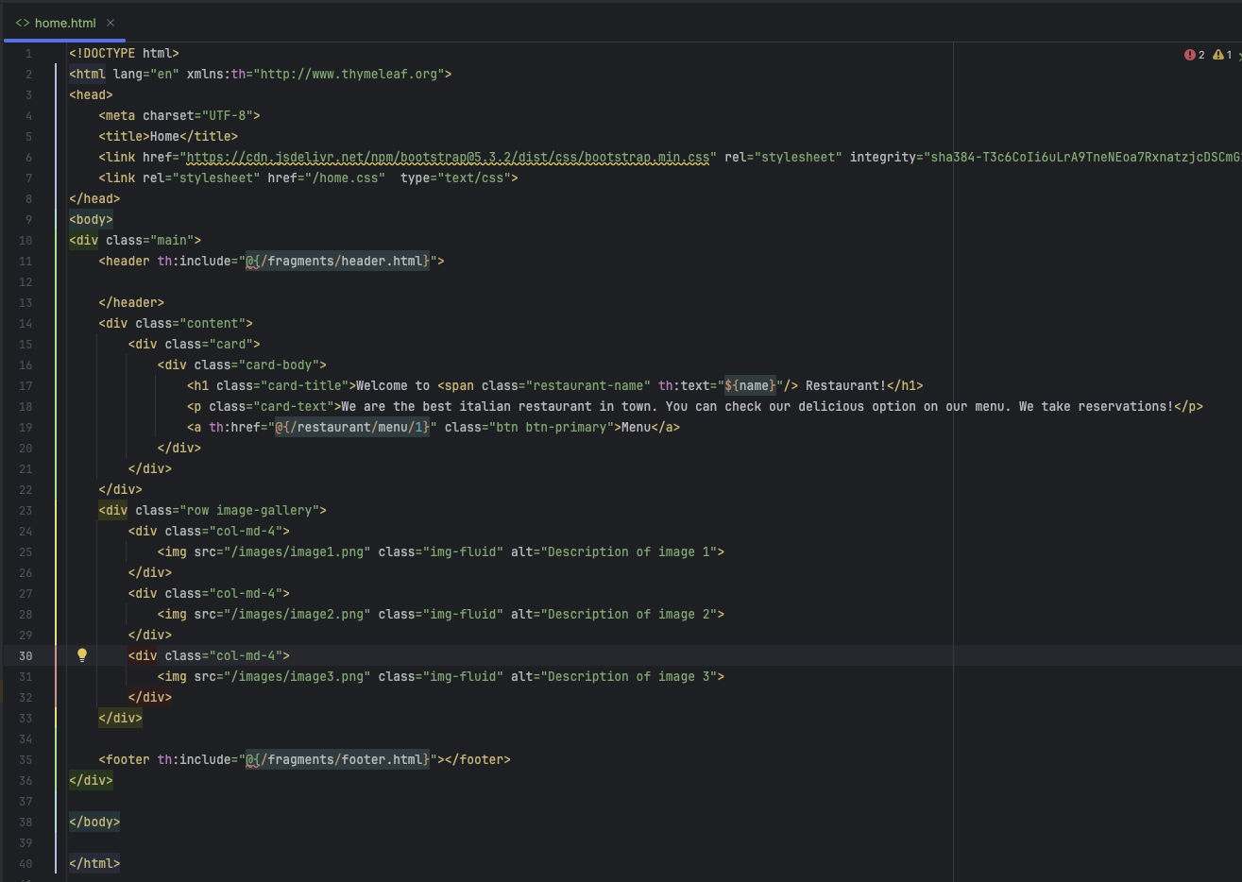

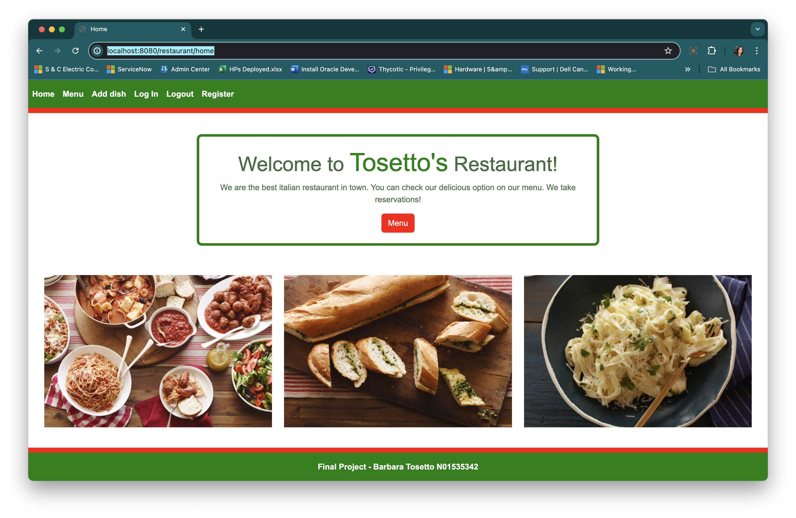

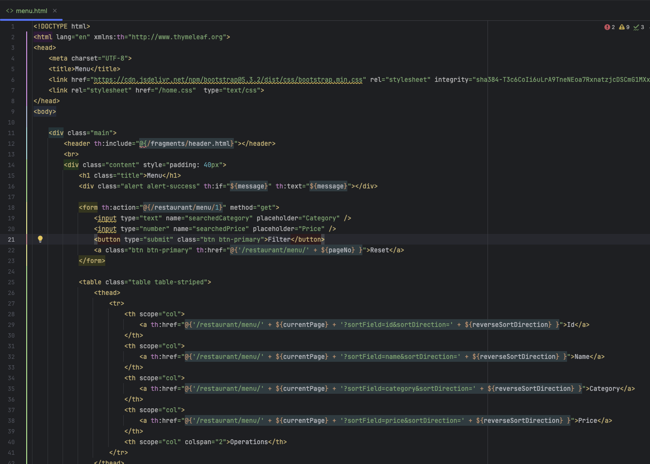

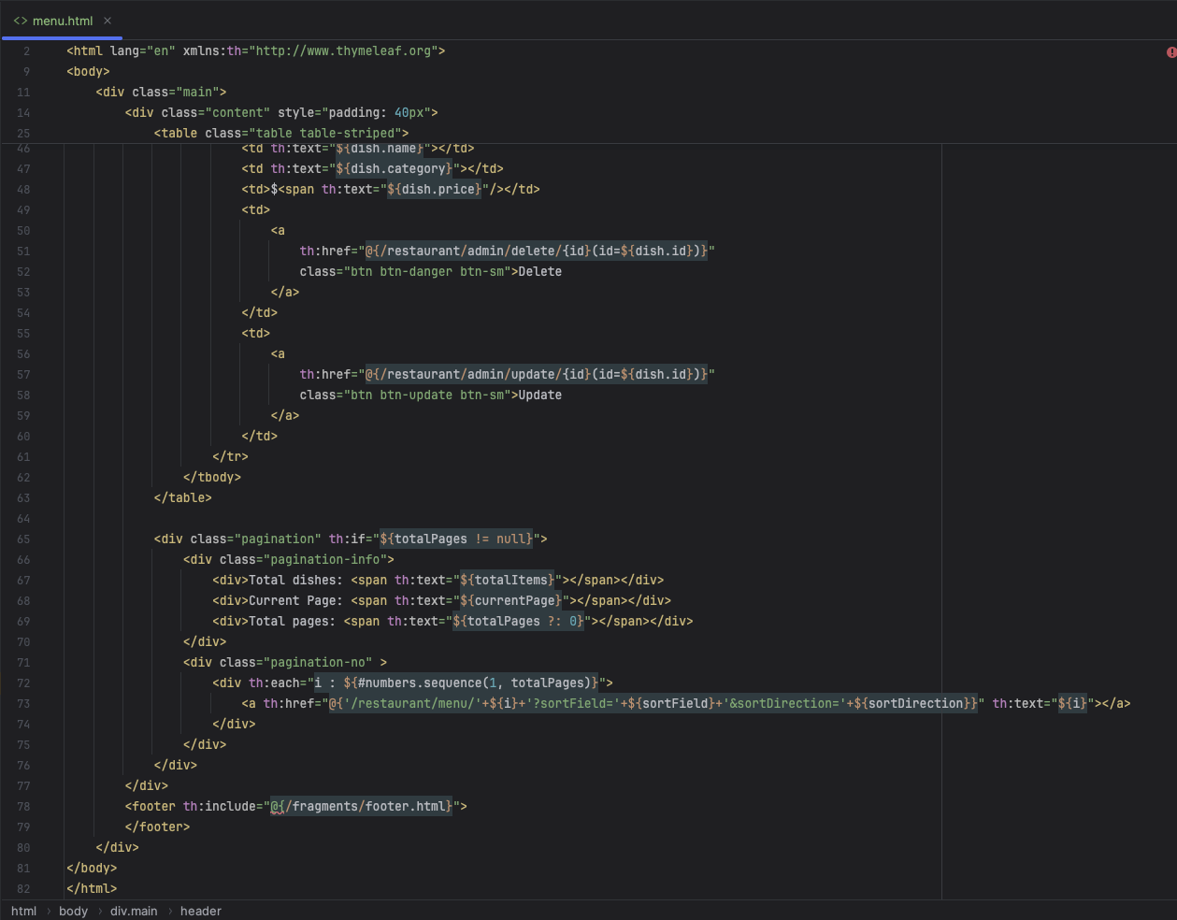

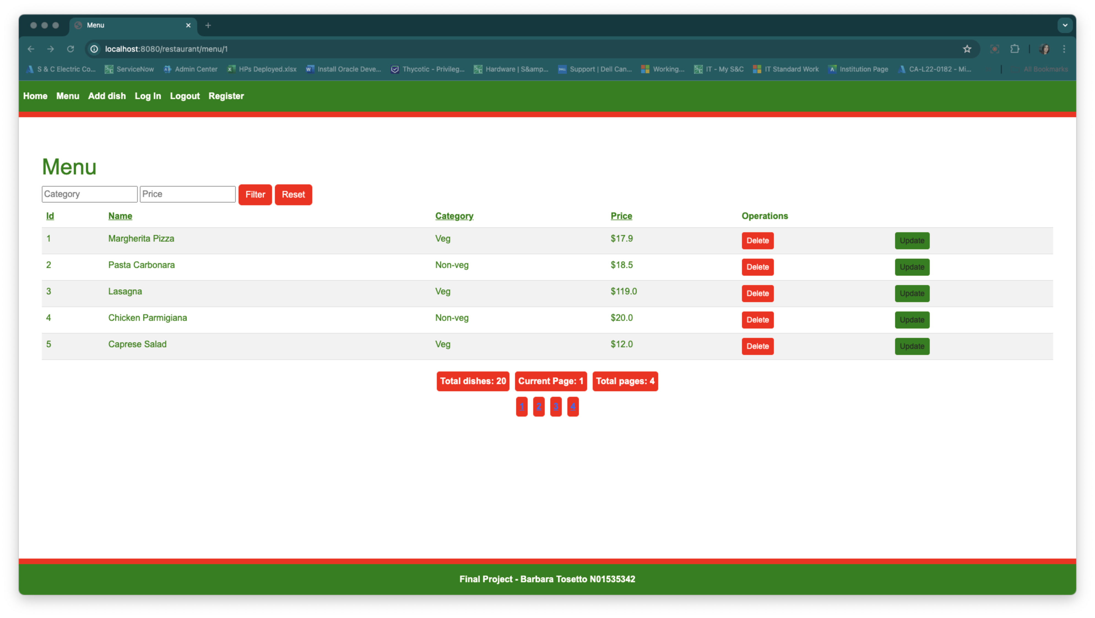

**Admin Section**

Contains templates such as add-dish.html under the admin folder, enabling administrative tasks like adding or updating dishes.

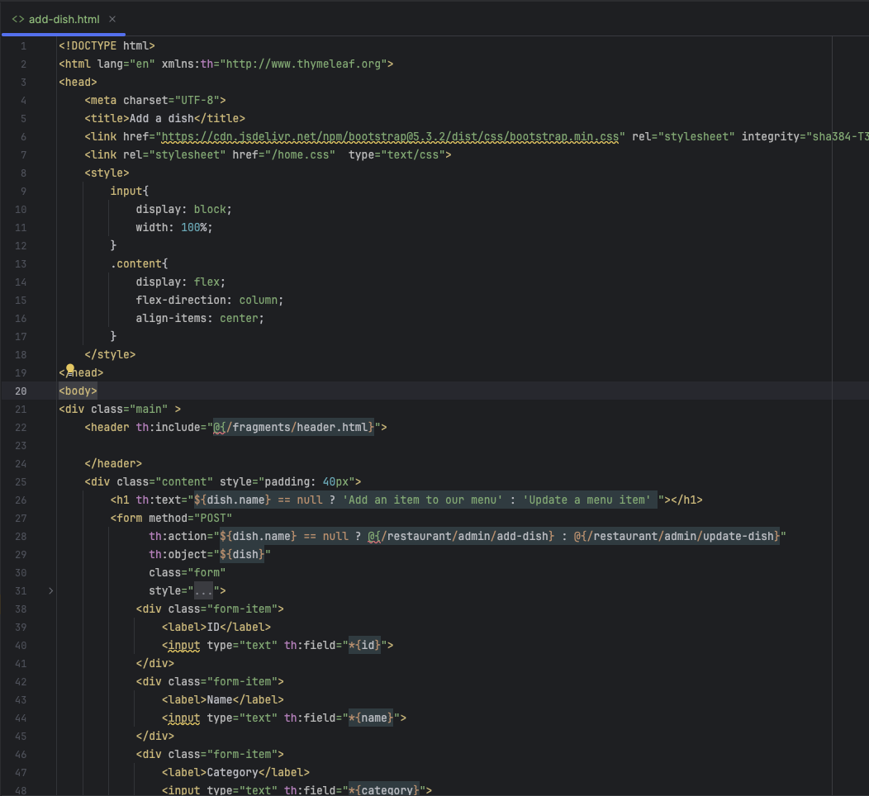

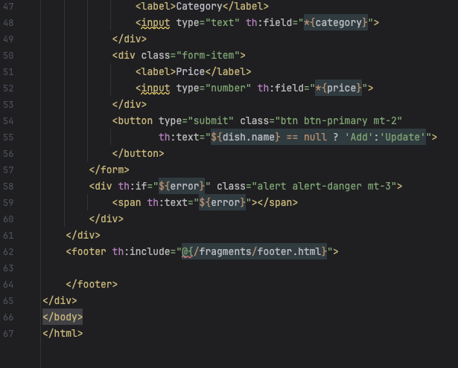

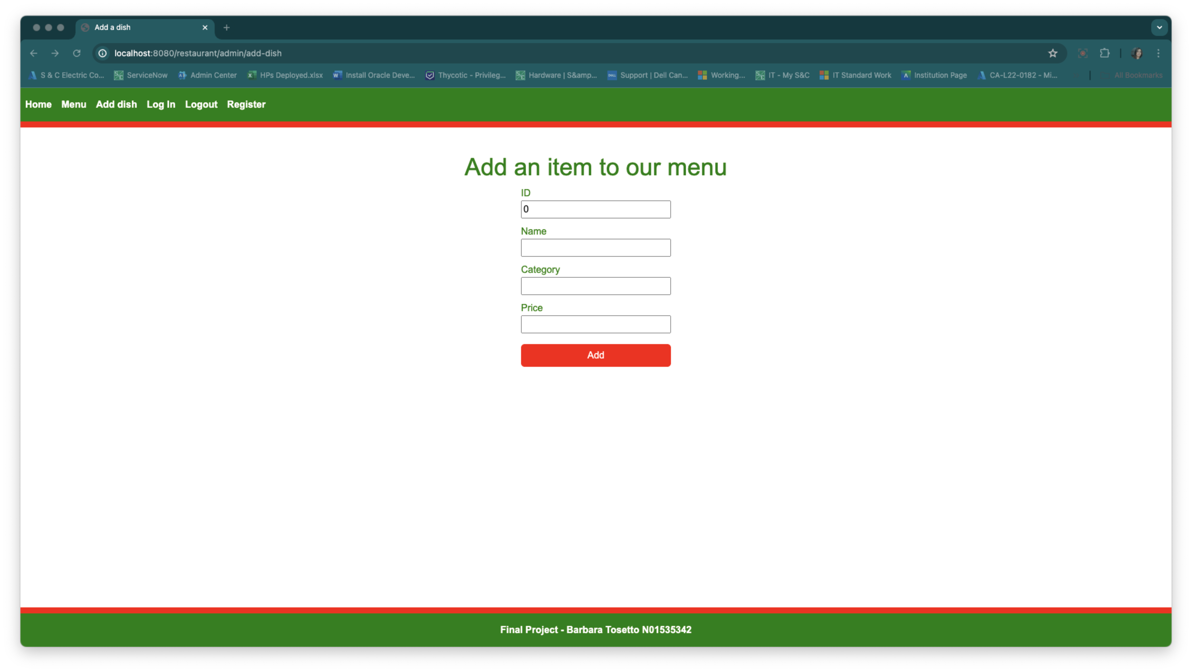

**Authentication Pages**

Found under the auth folder, with templates for login (login.html), registration (register.html), and error handling (error.html), facilitating user authentication and authorization processes.

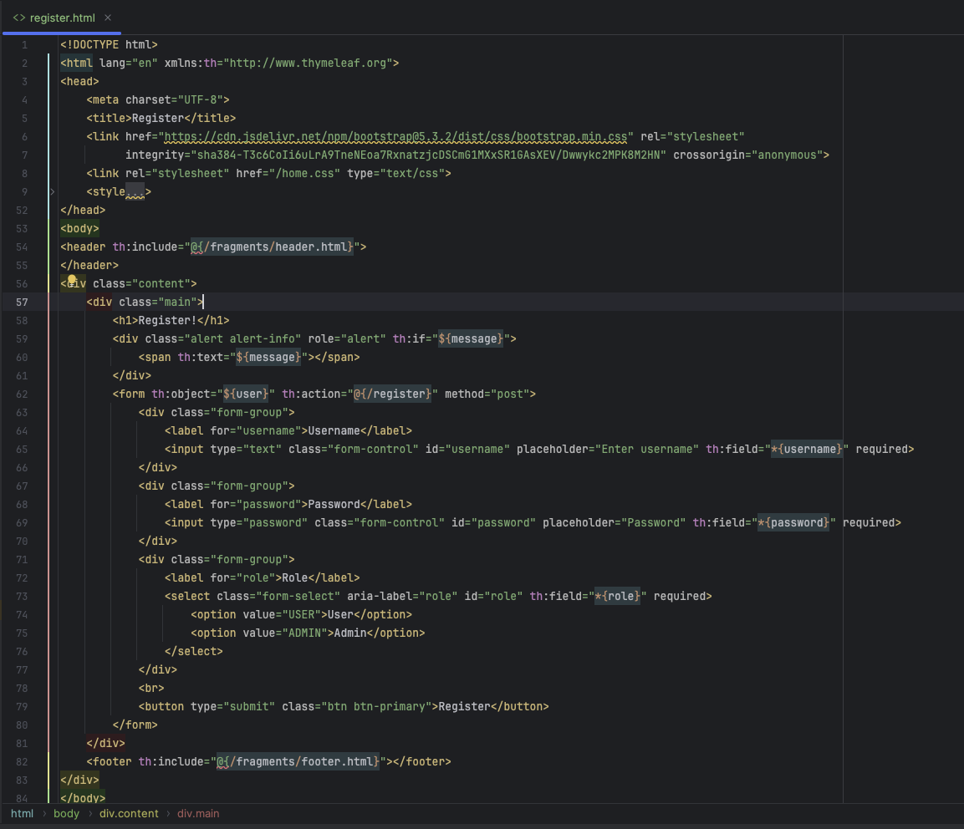

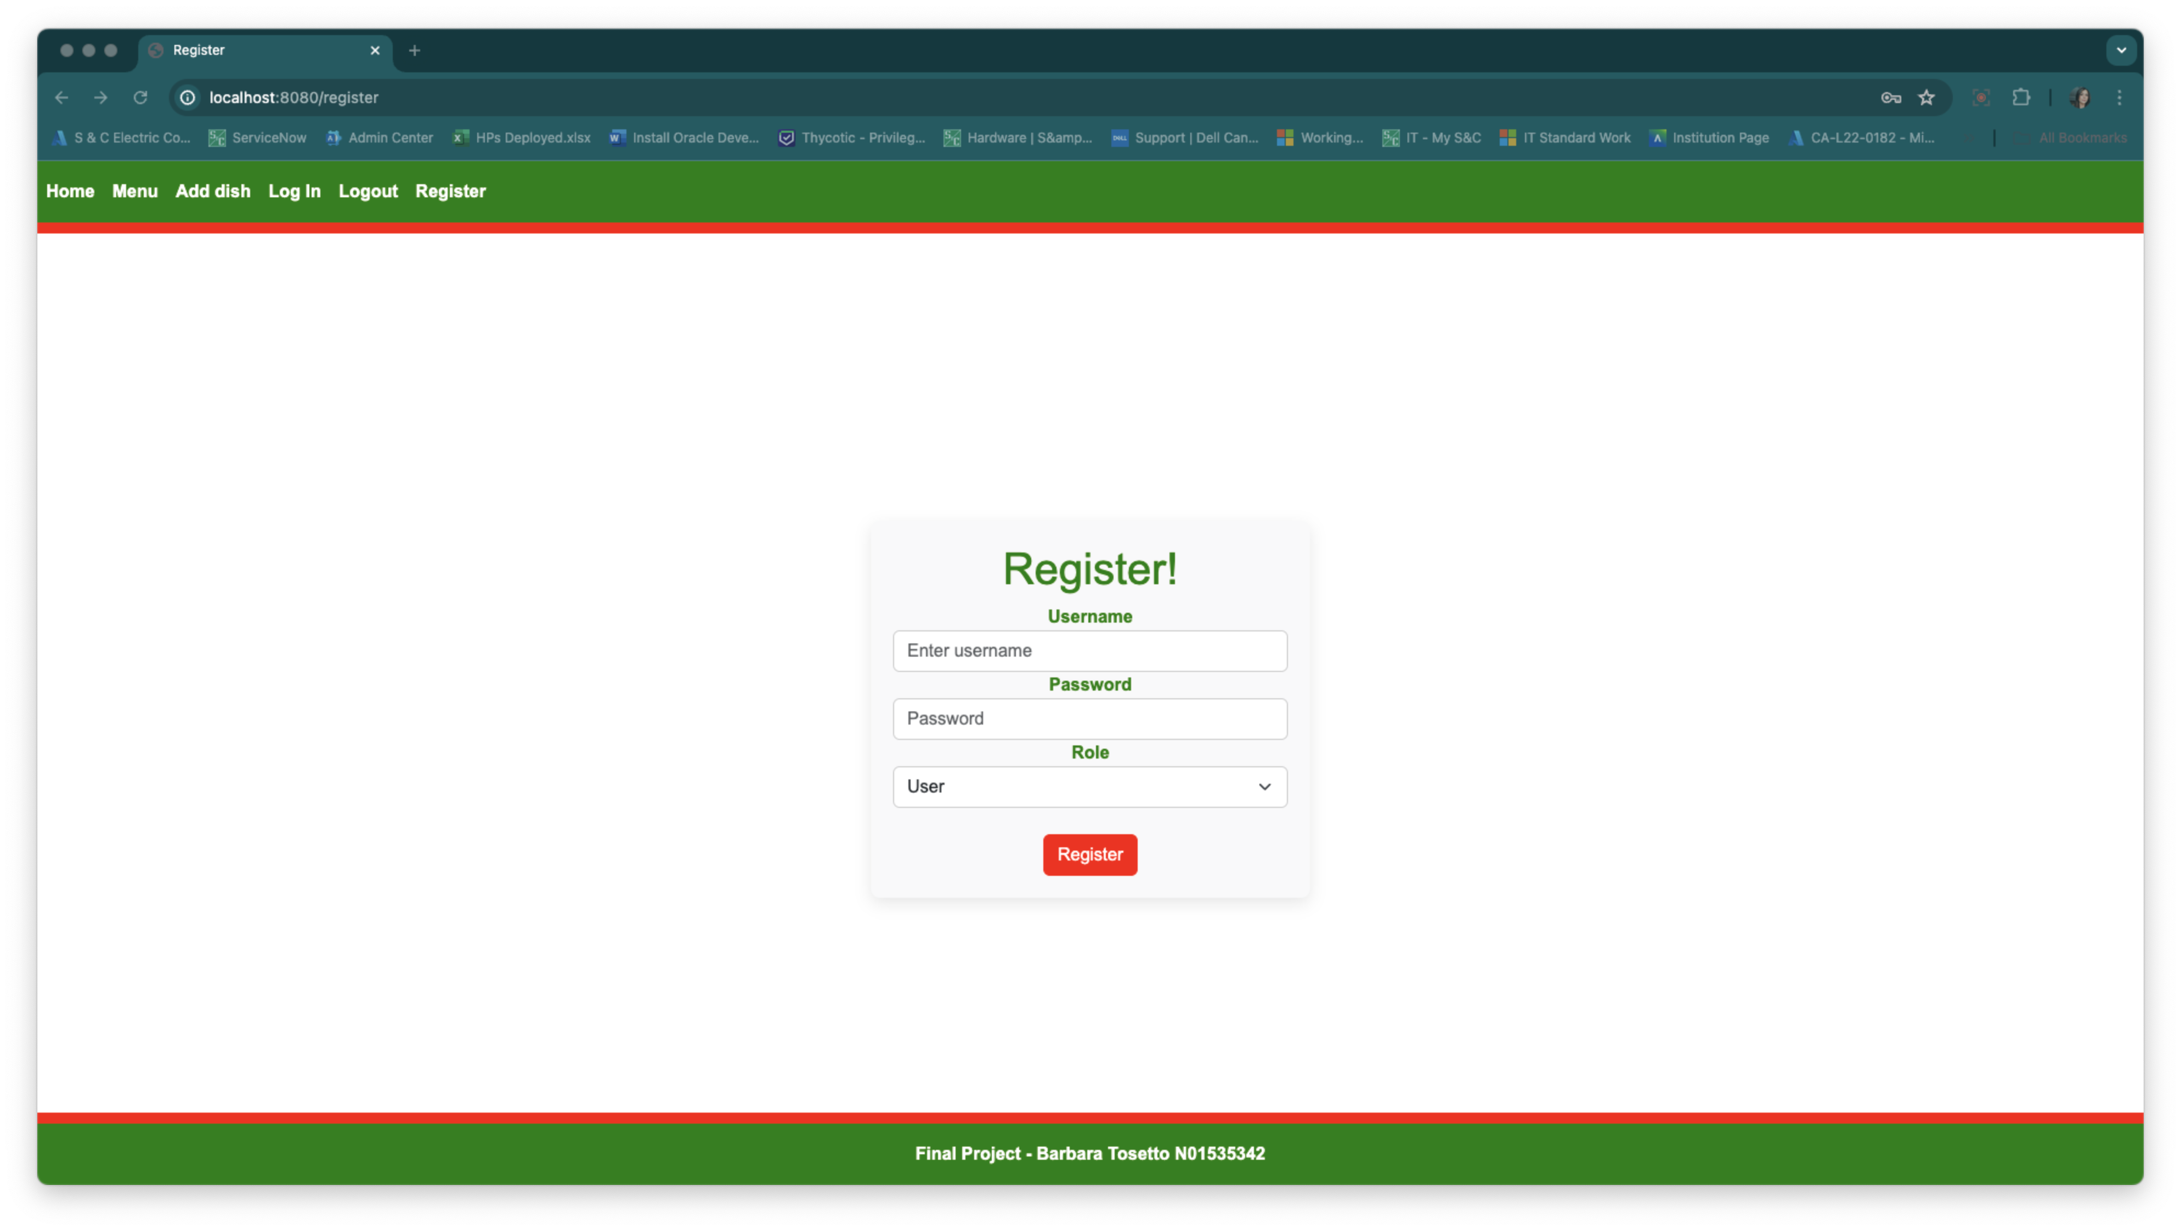

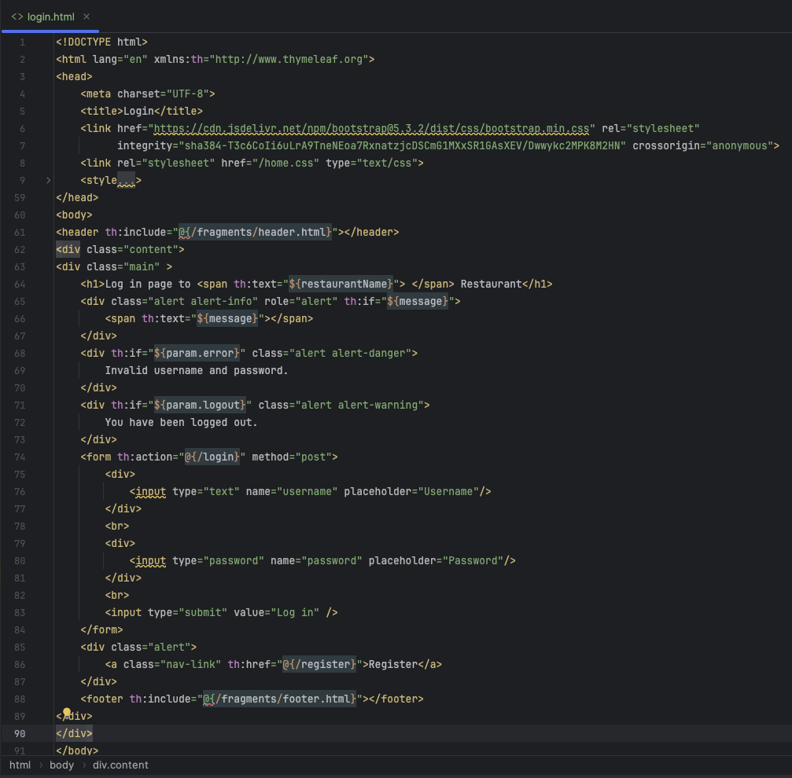

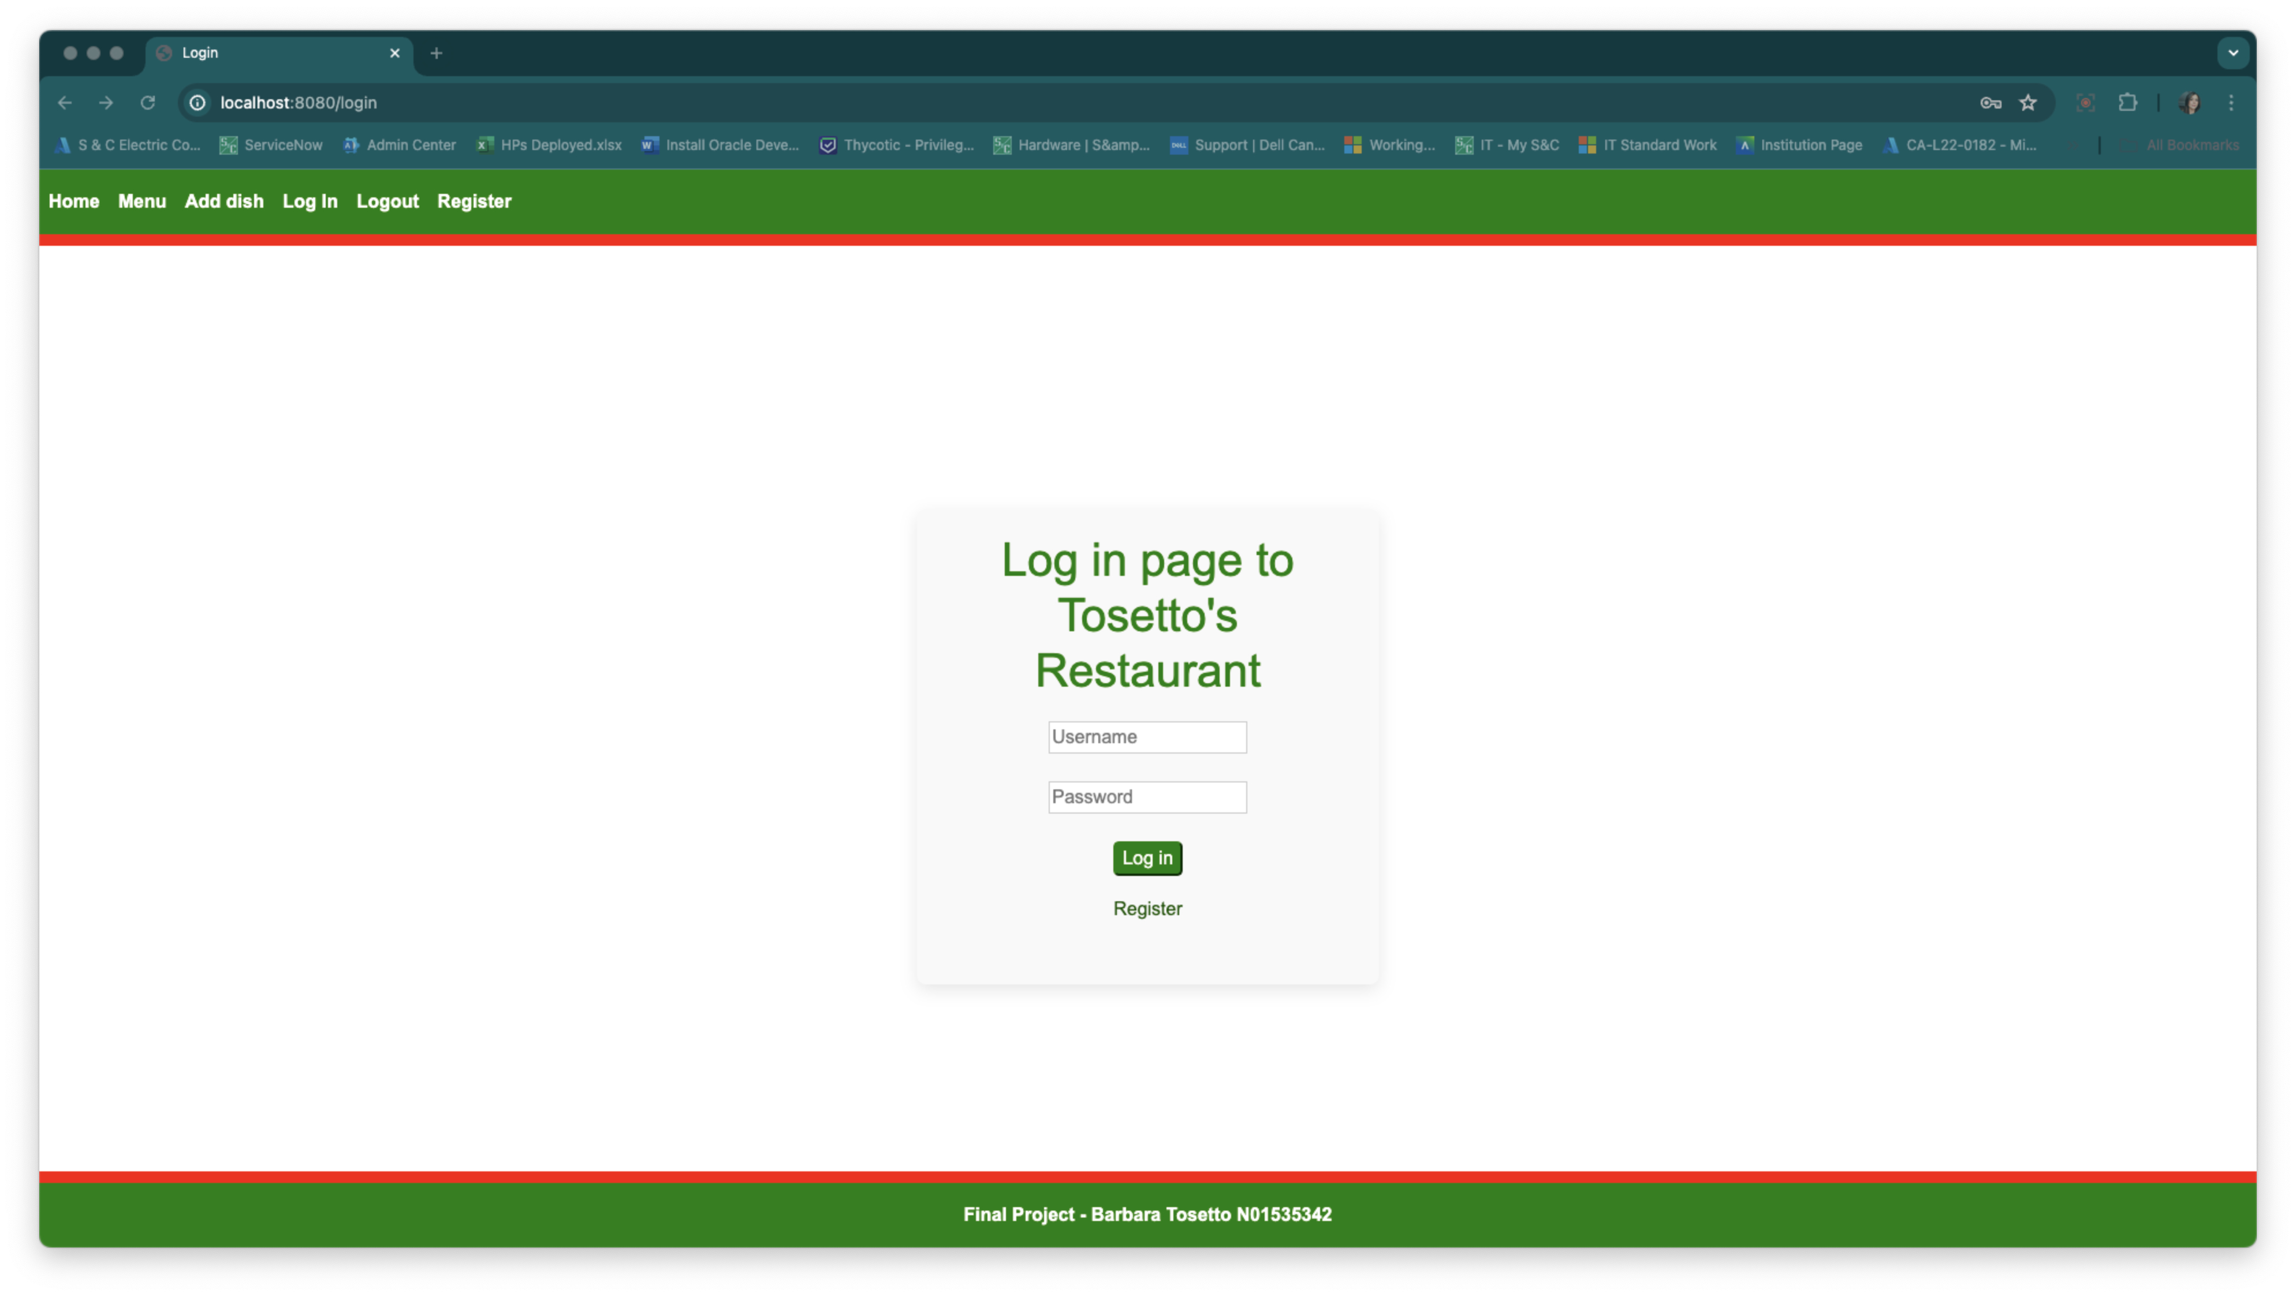

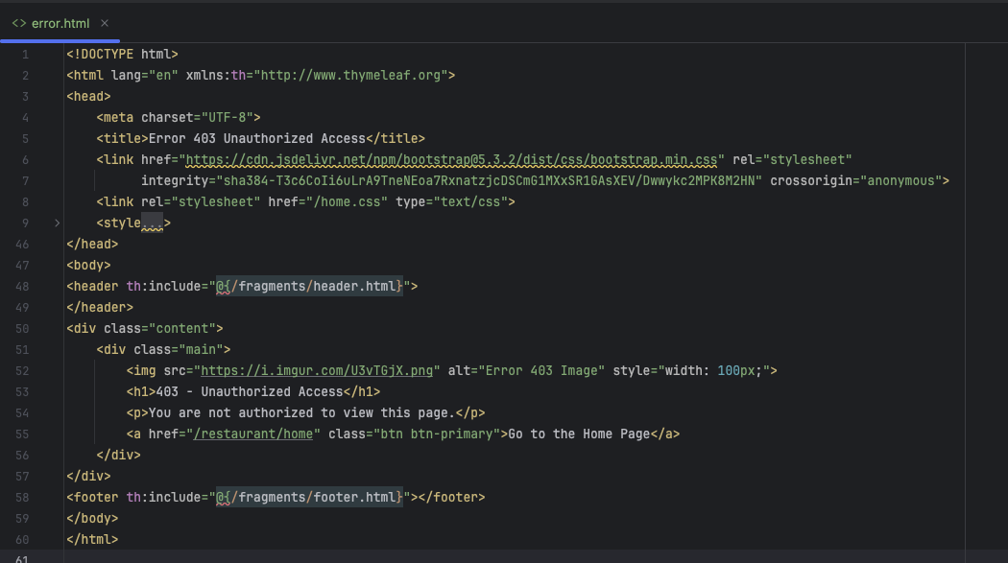

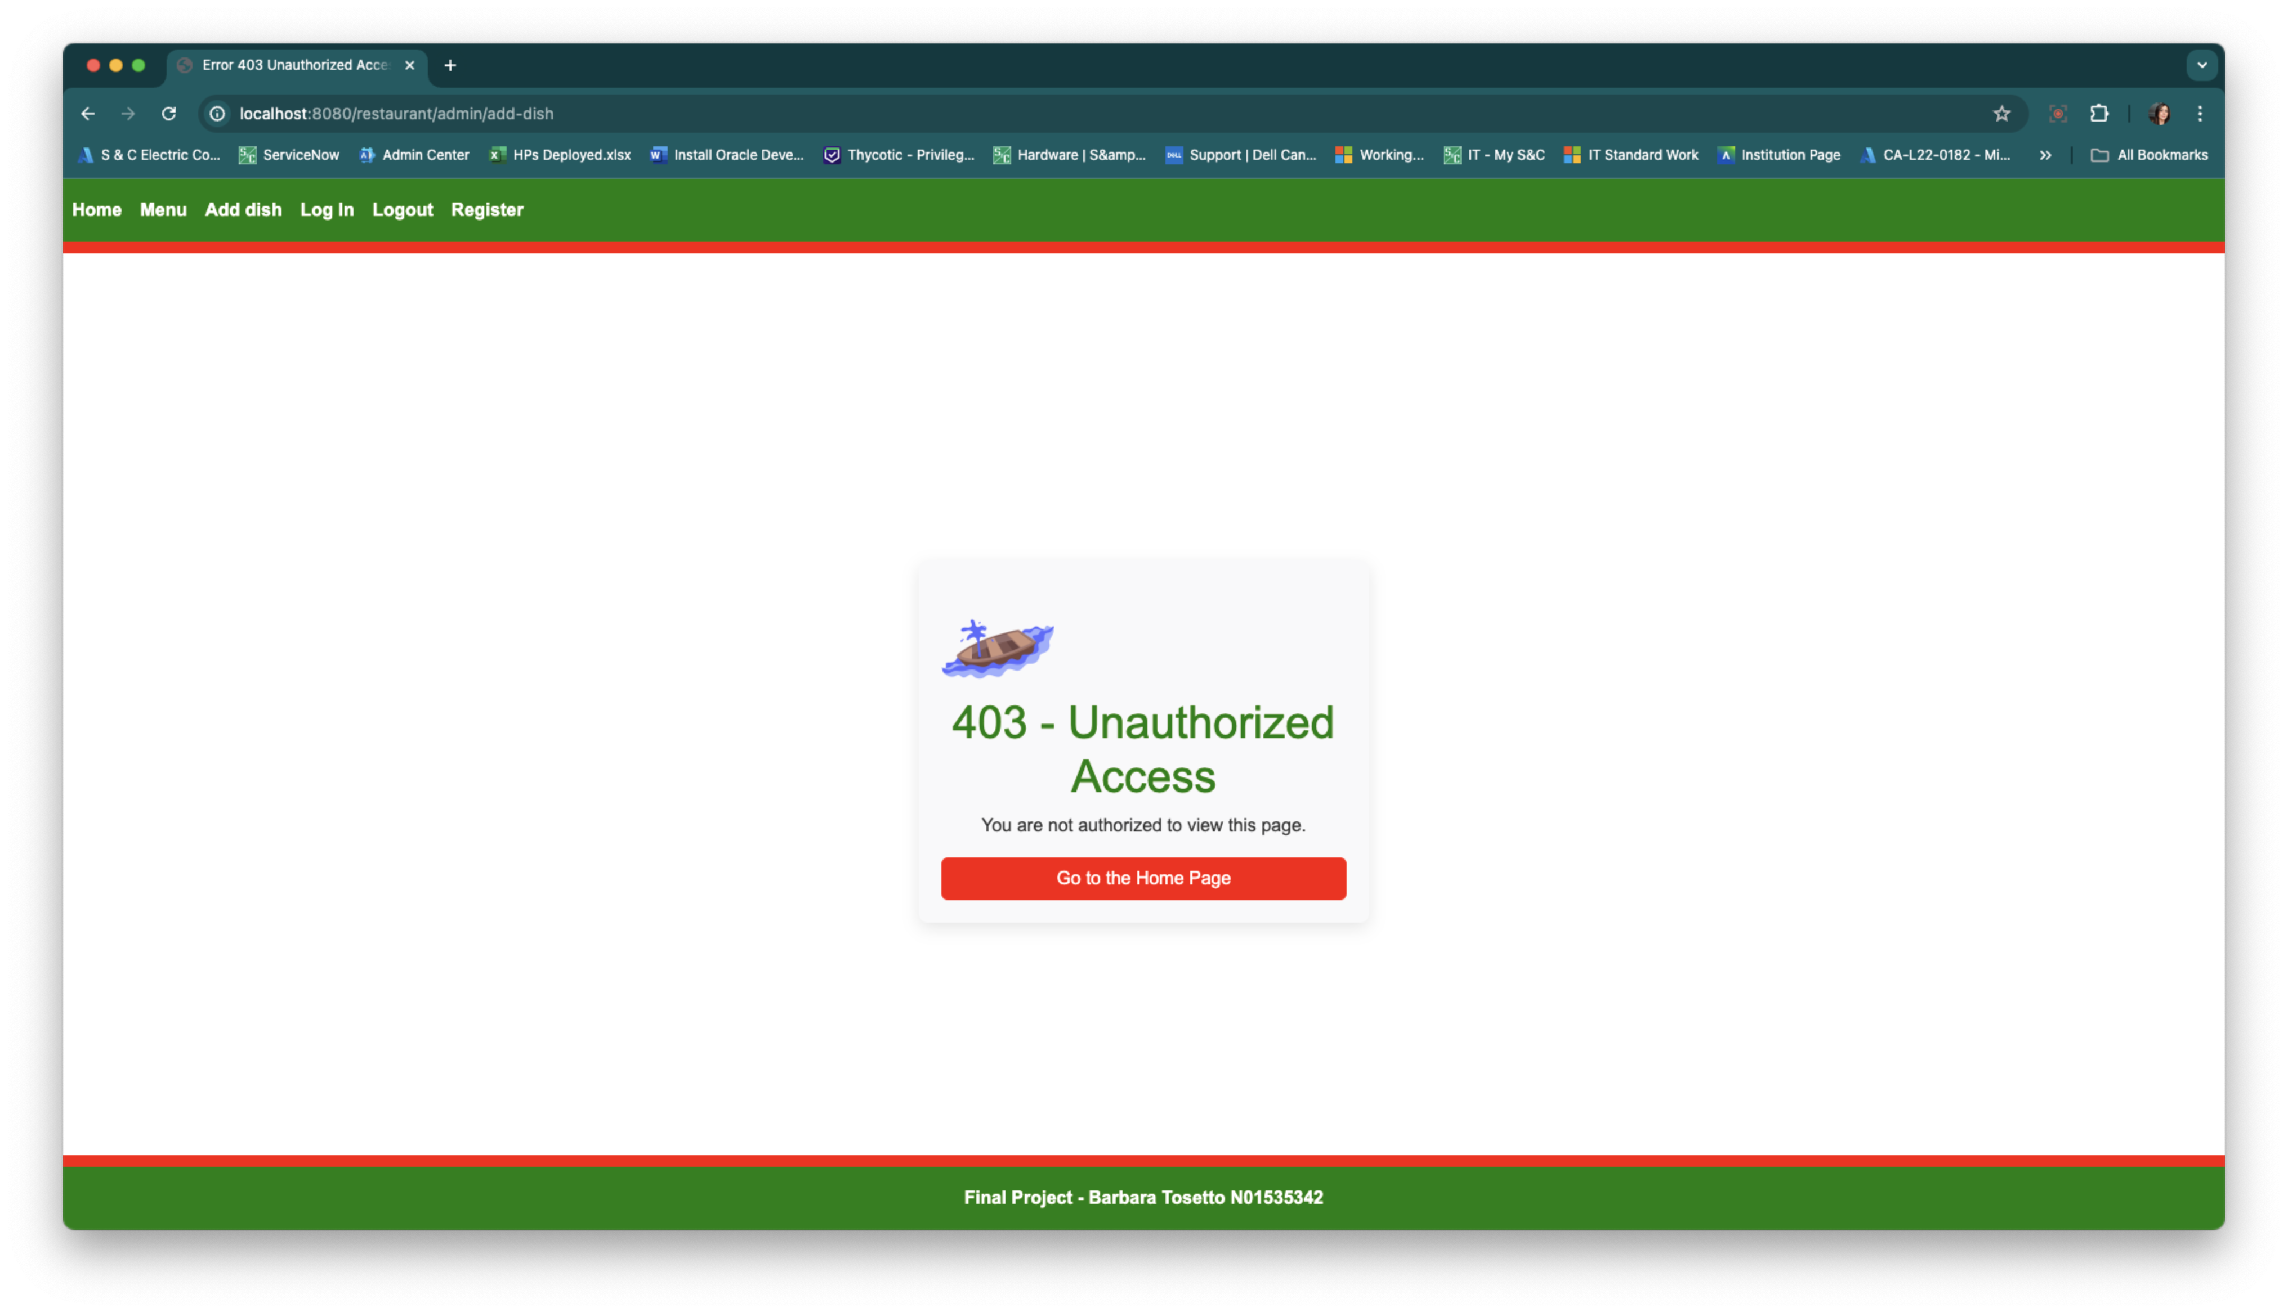

**Reusable Fragments**

Such as header.html and footer.html in the fragments folder, which are incorporated across various templates to ensure a consistent layout and reduce redundancy.

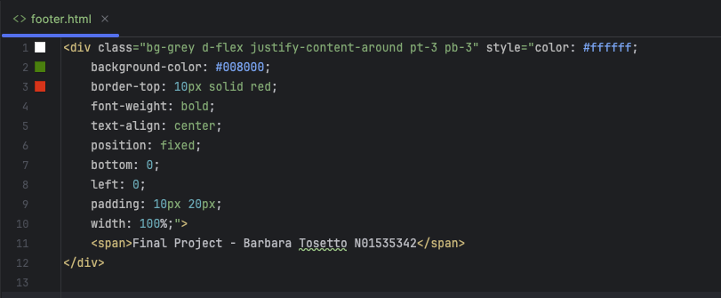

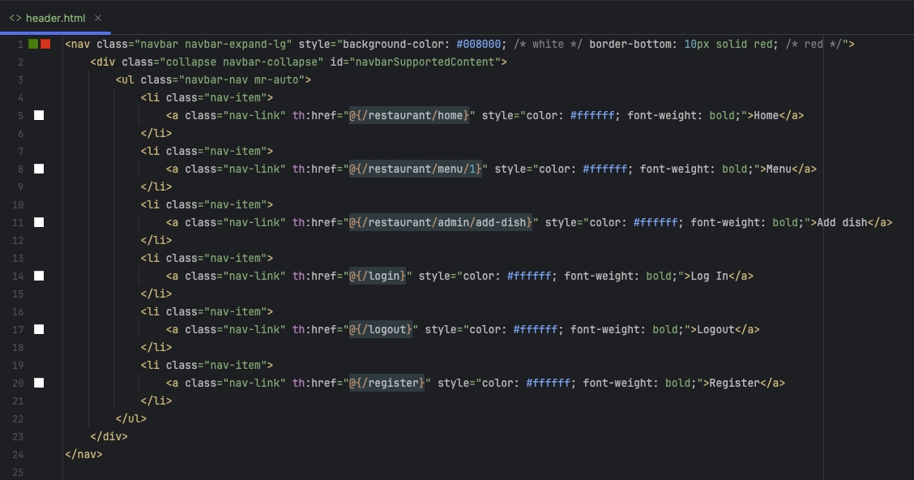

**Static Resource**

Housed in the static folder, including CSS files and images that help in styling and theming the pages, enhancing the overall look and feel of the application.

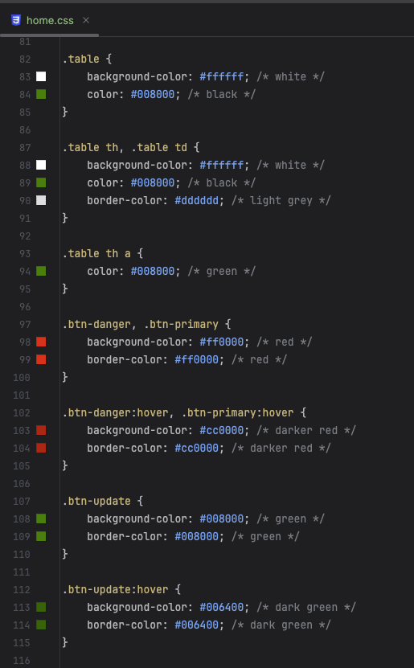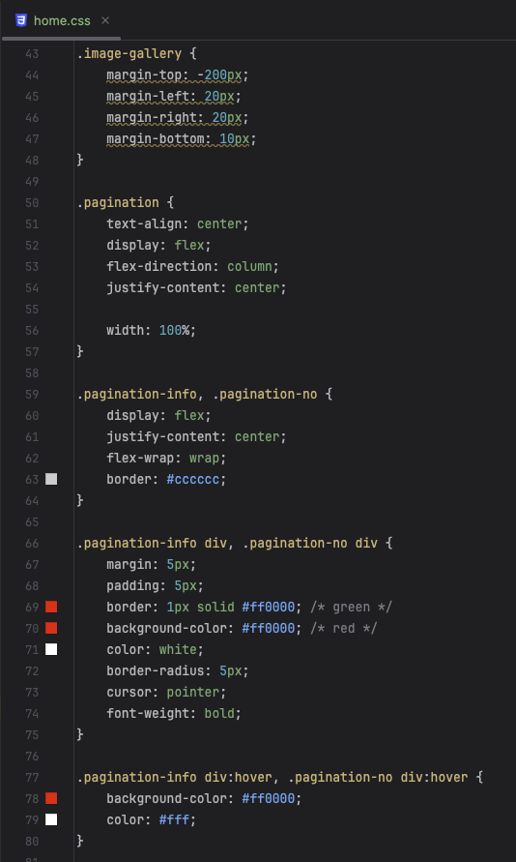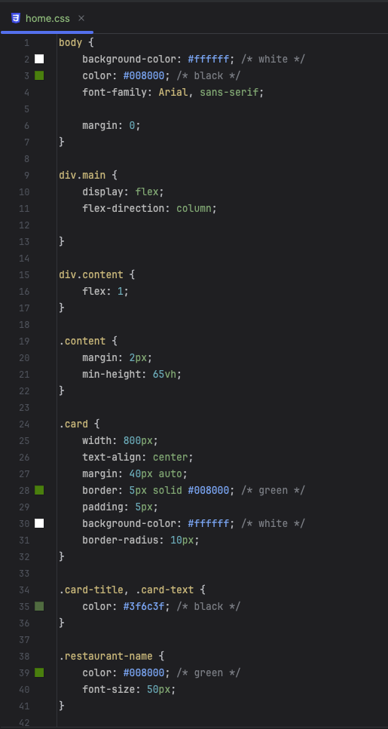

Application Screenshots

Even if the user is not logged in, the home page is available, also the menu page.

Home page: <http://localhost:8080/restaurant/home>



Menu: http://localhost:8080/restaurant/menu/1

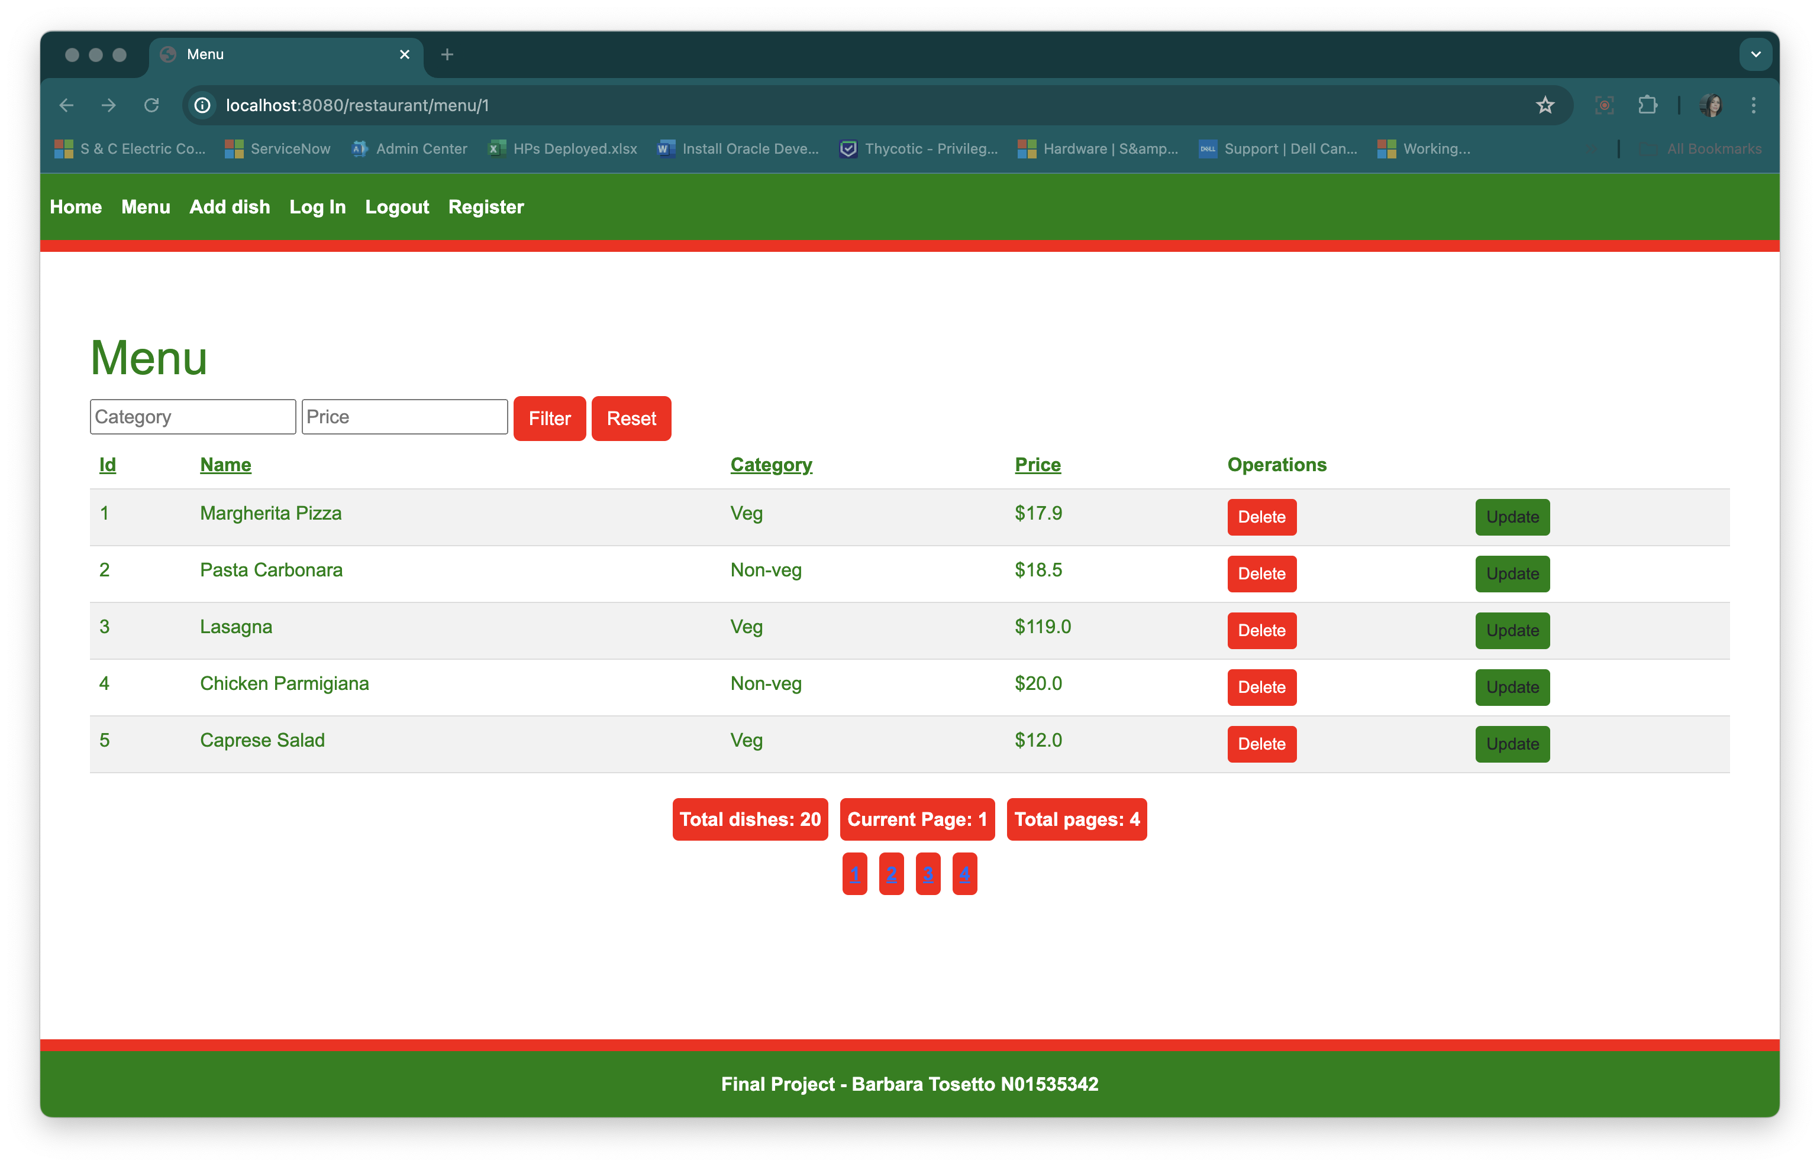

But if the user is not logged in and navigates to “Add Dish” page, or tries to perform “Delete” or “Update”, they will be redirected to an error page:

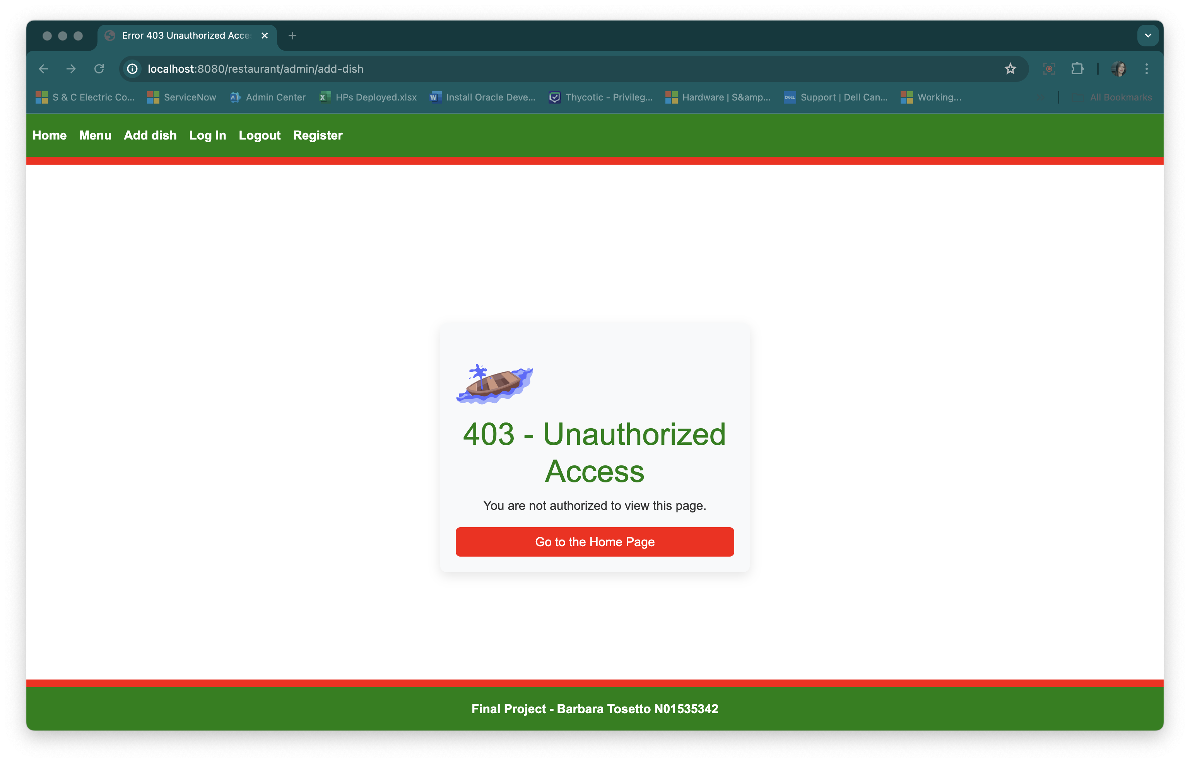

The user can Register as “Admin”, or “User” in order to have access to all features of the application.

Register Page: <http://localhost:8080/register>

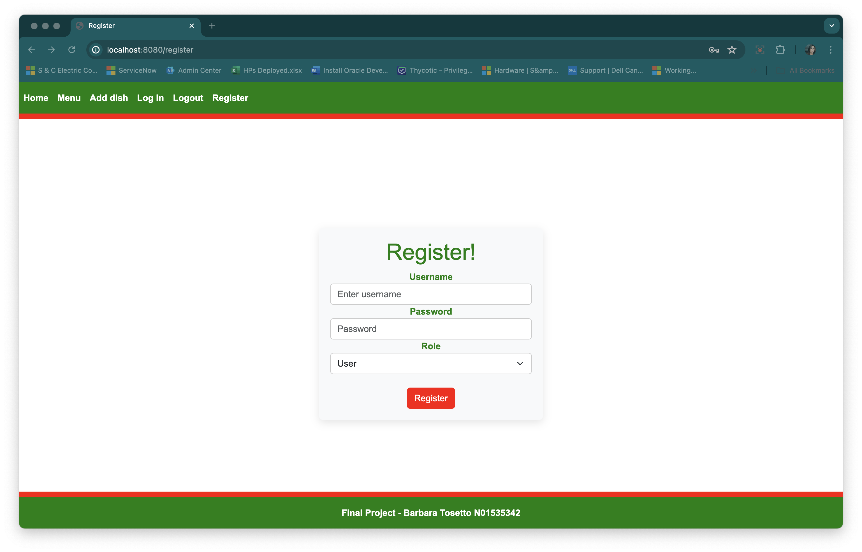

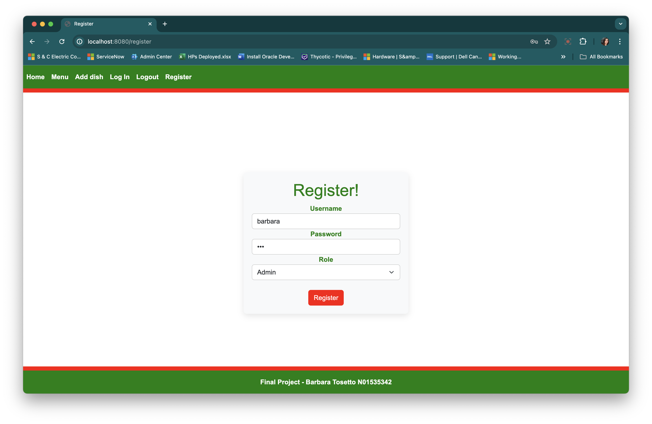

After registering, the user is headed to the Log In page ( <http://localhost:8080/login?message=Registration%20successful> ). Finally, the user will be redirected to the Restaurant’s home page.

Log In page: http://localhost:8080/login

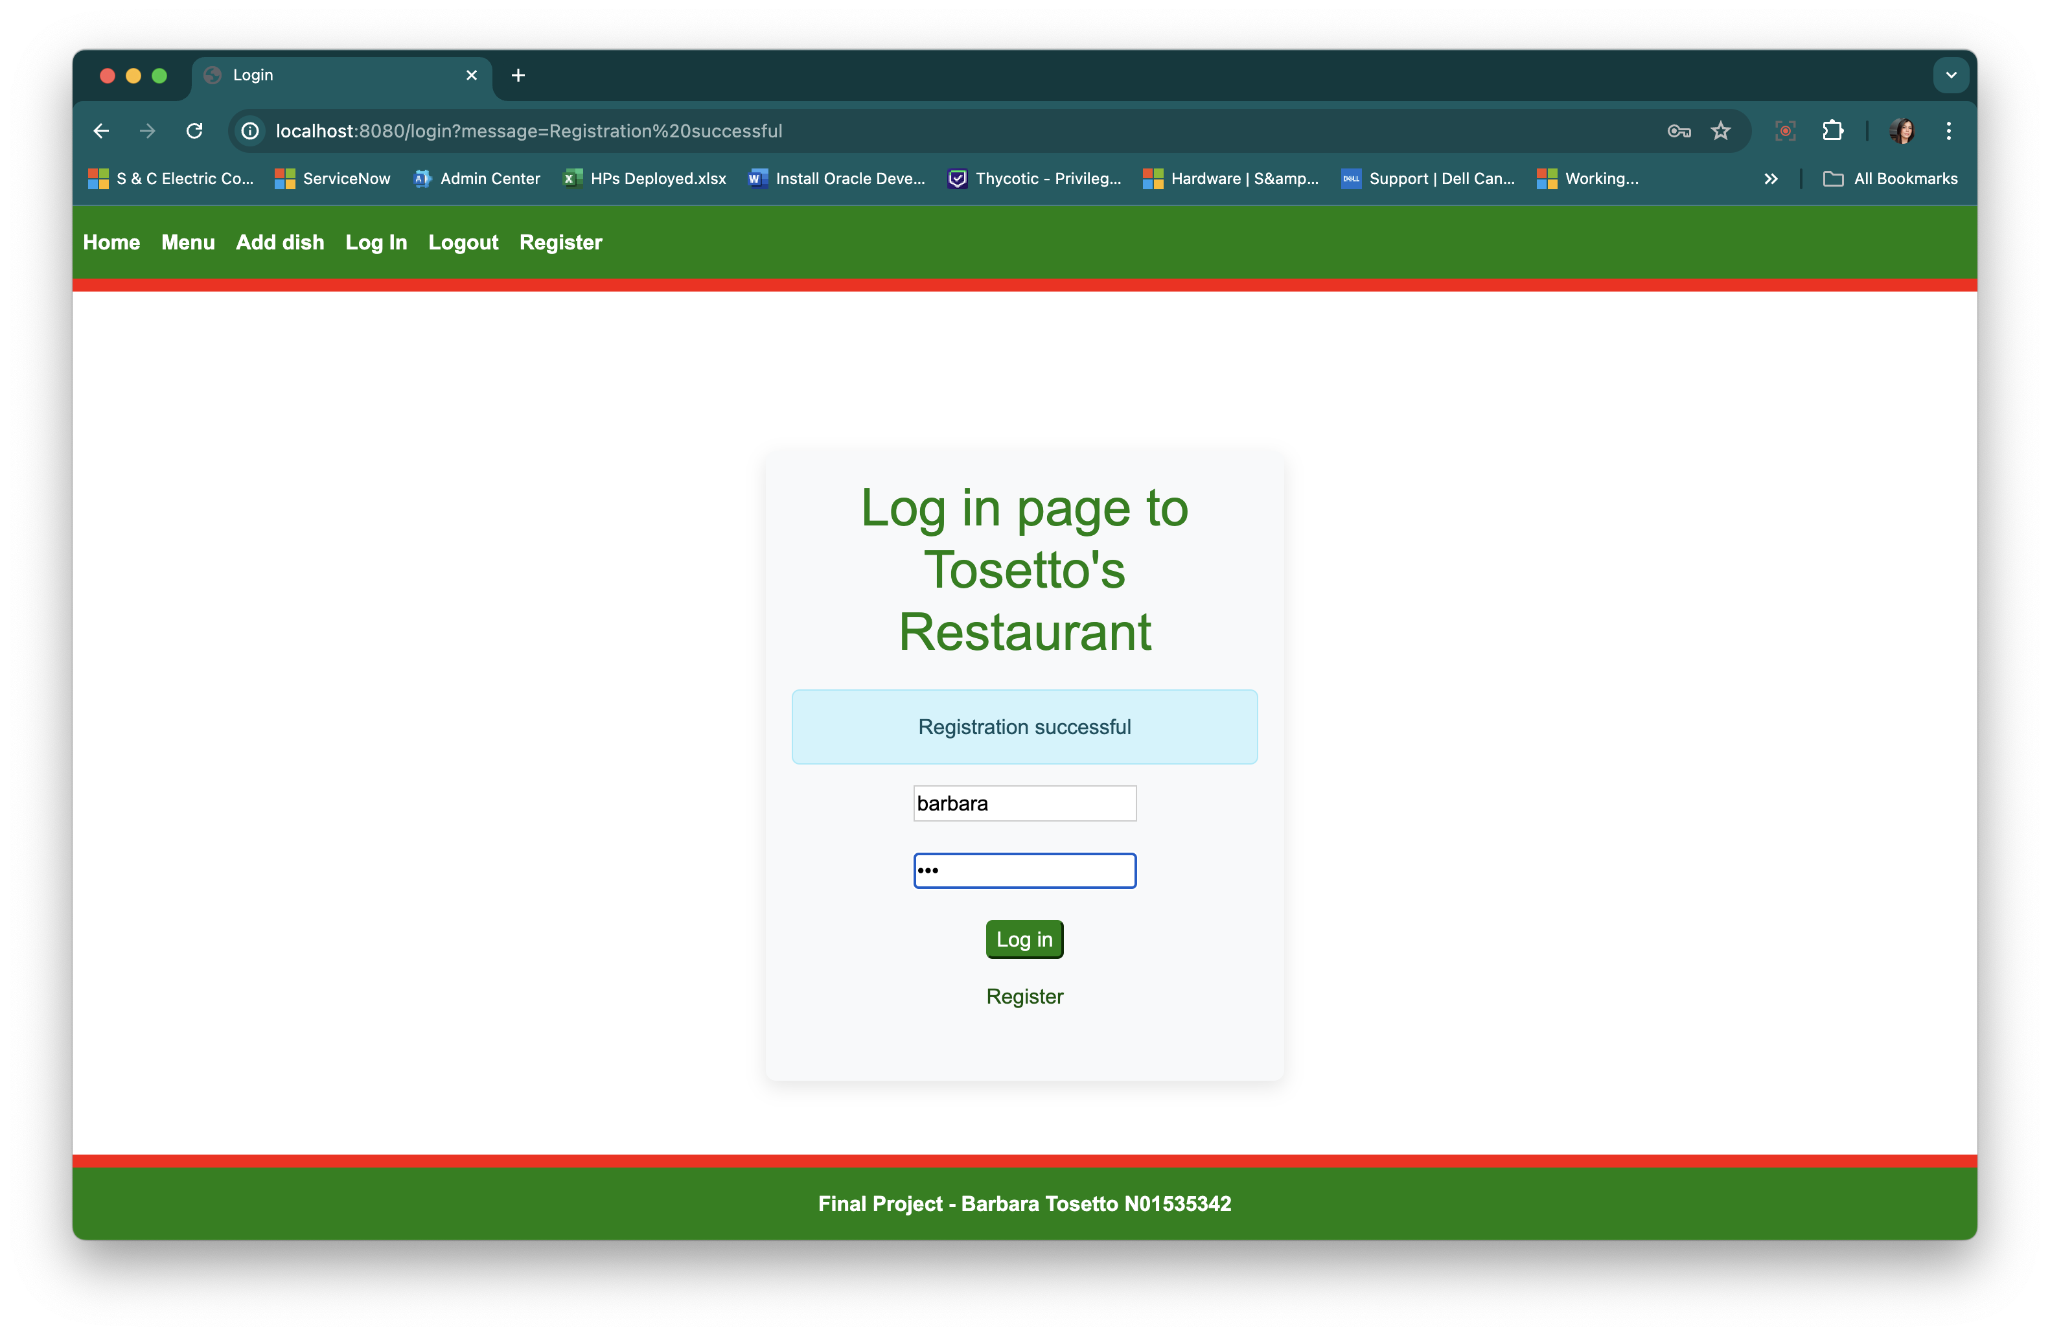

Now the feature to add a dish is available:

Add-Dish: http://localhost:8080/restaurant/admin/add-dish

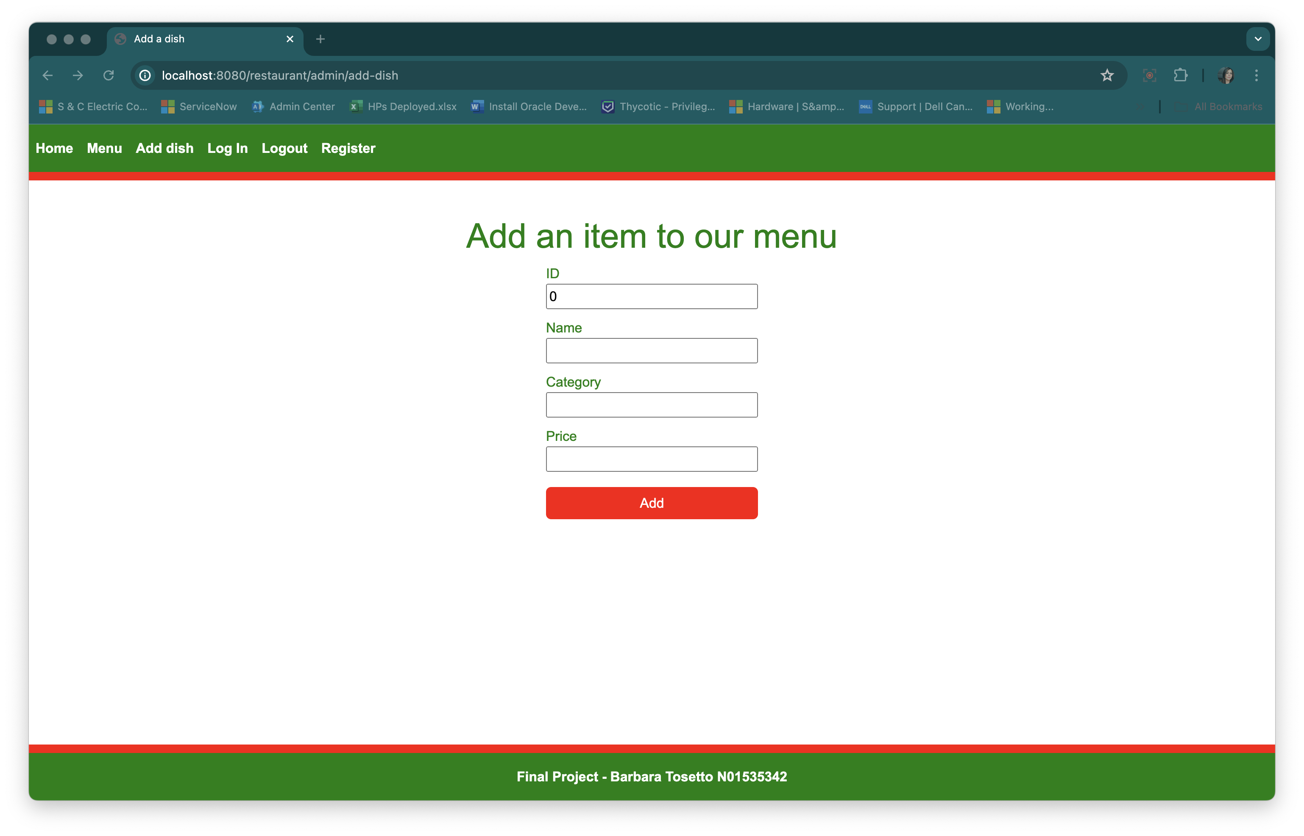

Also, the feature to update and dele dishes is available if the user is logged as “ADMIN”



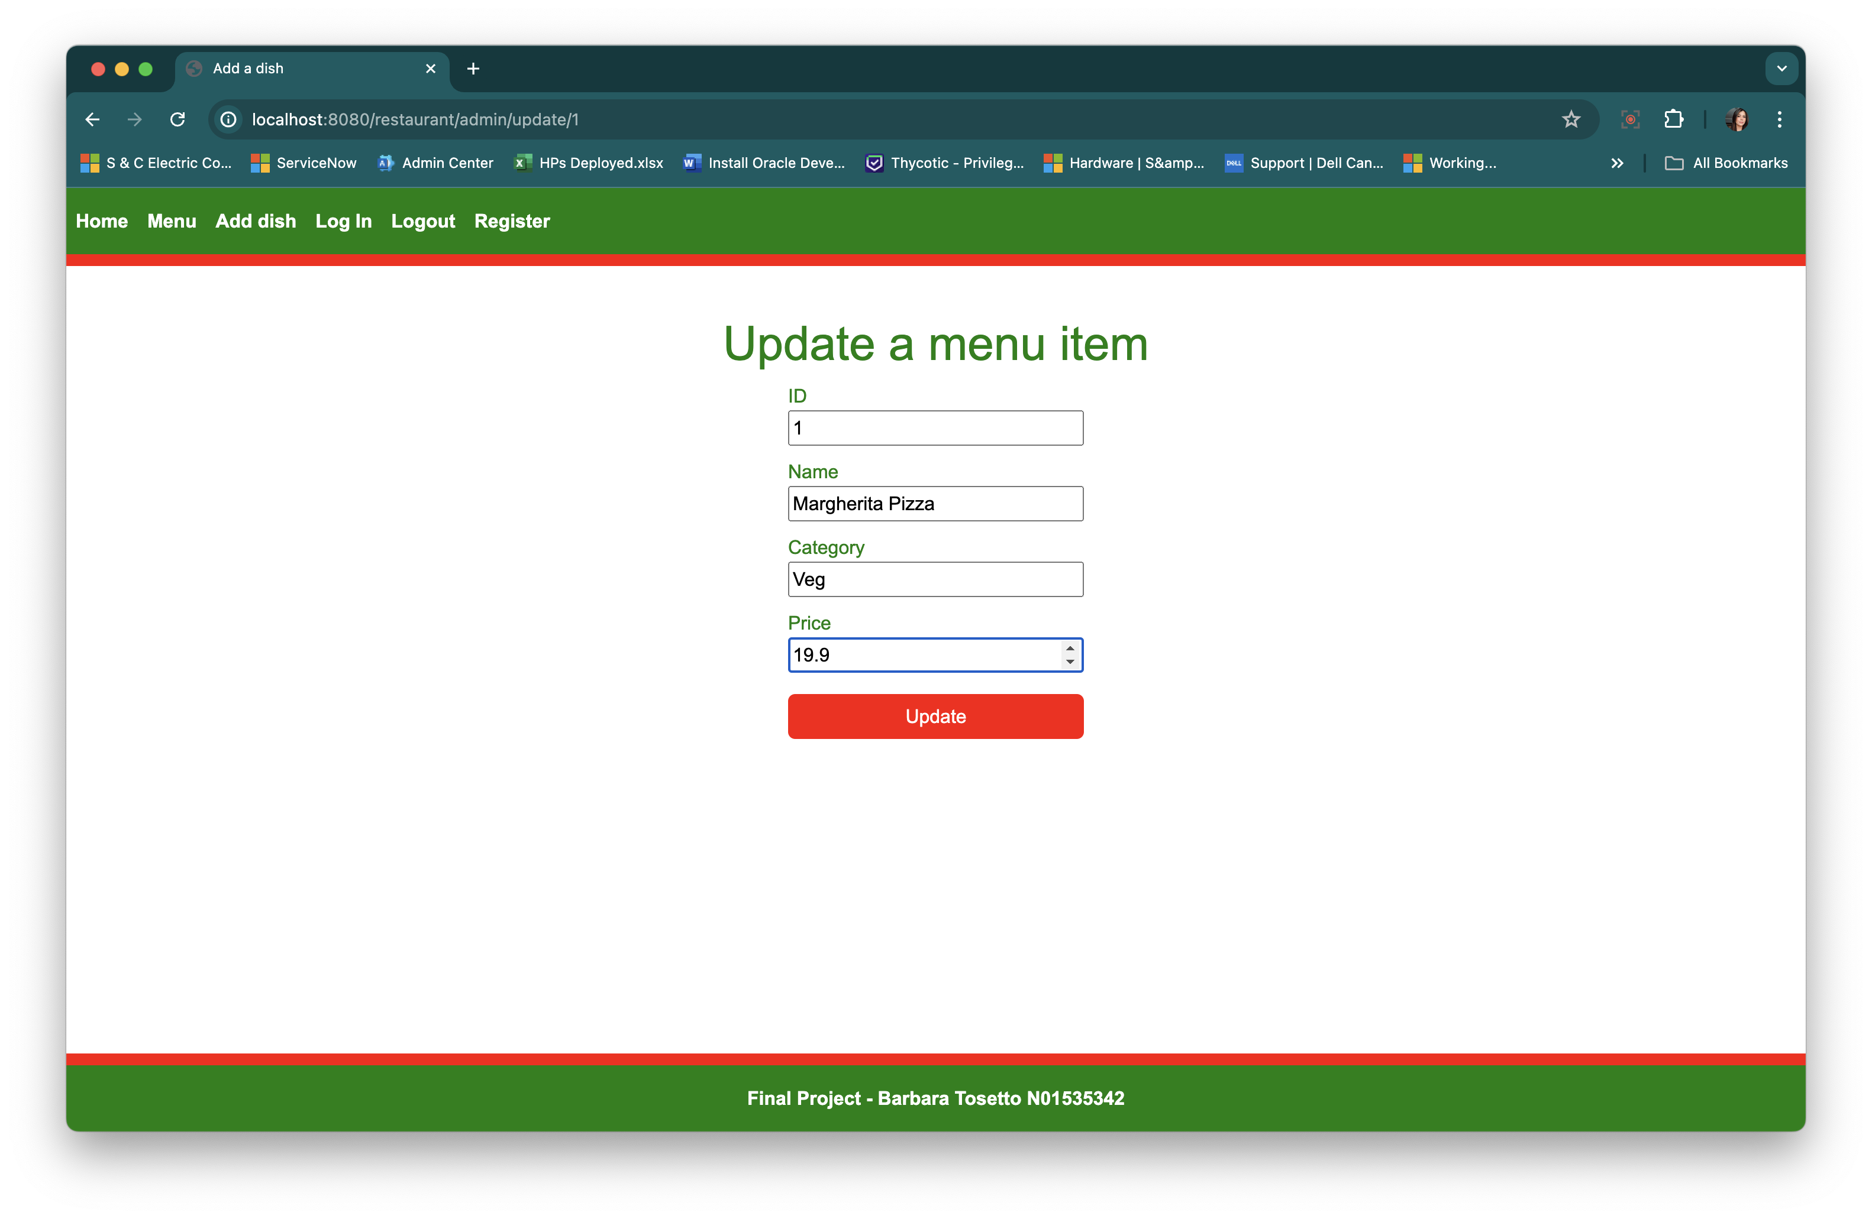

The price of the first item of the list was updated:

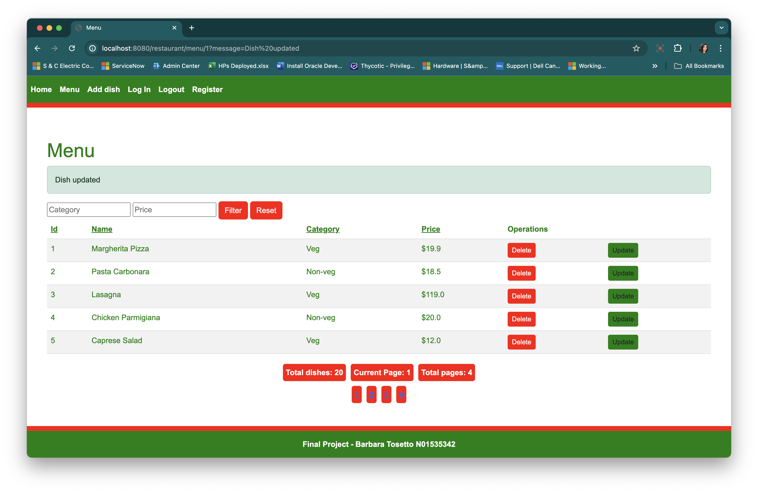

And then the first item was deleted:

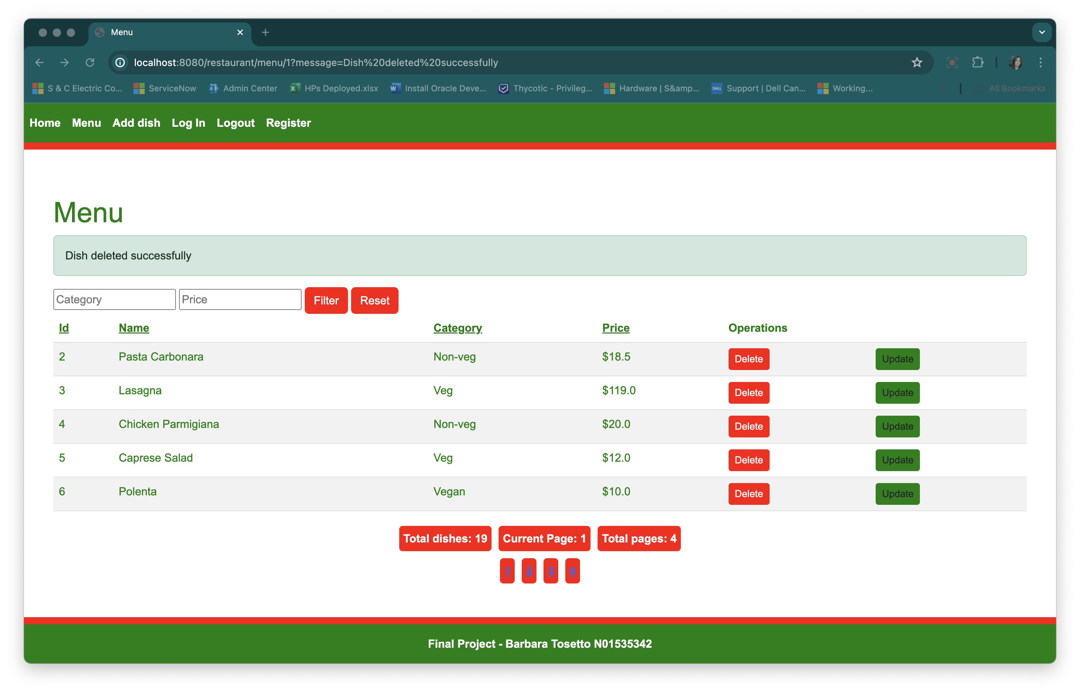

The Logout link on the navbar disconnects the user and displays a successful on the log in page:

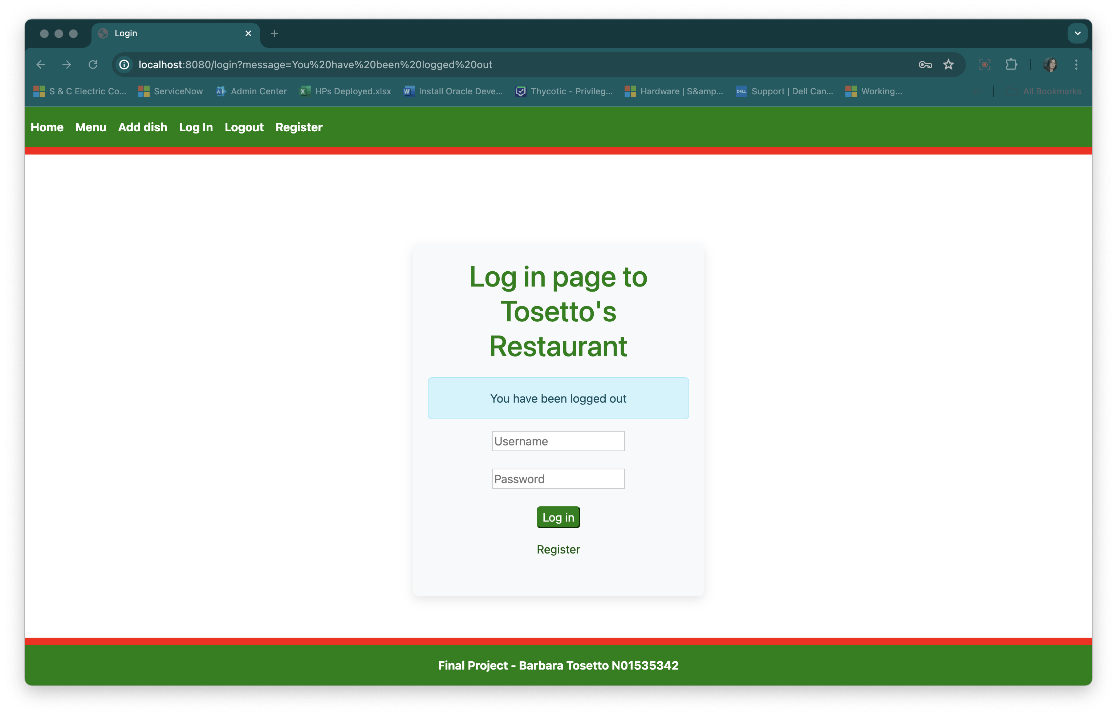

Access to H2-console:

